Implementation Screenshot Evidence

**Table 1- Customers**

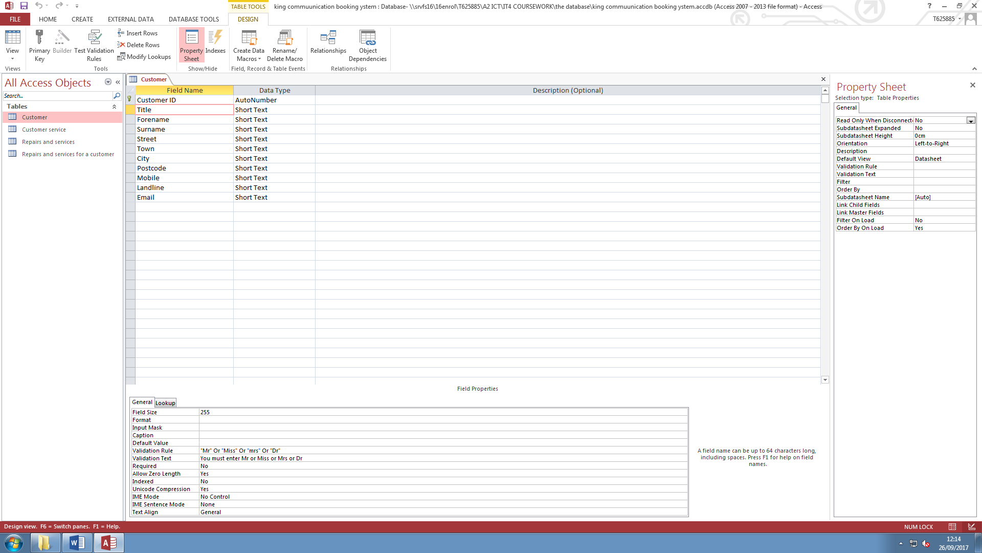

This is the customers table in the design view. The only primary key in the table is the ‘customer id’ and it has the data type auto number, so that the id number is generated automatically. The number is never repeated again making it unique and ideal for the database. This stops any repetition of data and makes accessing it quicker. I have used short text for the rest of the fields because this data that we have to add manually.

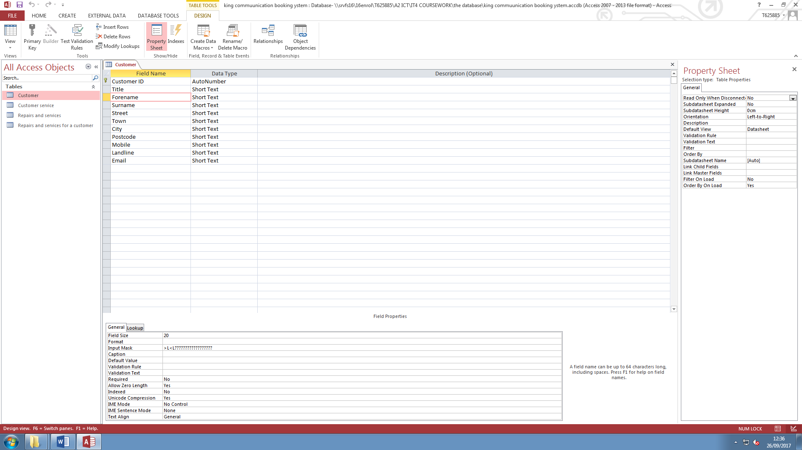

11There is a field size limit which I have set to 20 because names usually don’t be longer than 20 characters. I have used the input mask >L<L??????????????????, in the forename, surname, street and town fields. I used the greater than symbol ‘>’ character to make the first letter in the name to always be character. The ‘L’ means that a character has to be inputted. The used the less than symbol ‘<’ to make the rest of the characters lowercase. Then I used another ‘L’ to make sure that there are a minimum of 2 characters inputted because you don’t get a name smaller than 2 characters.

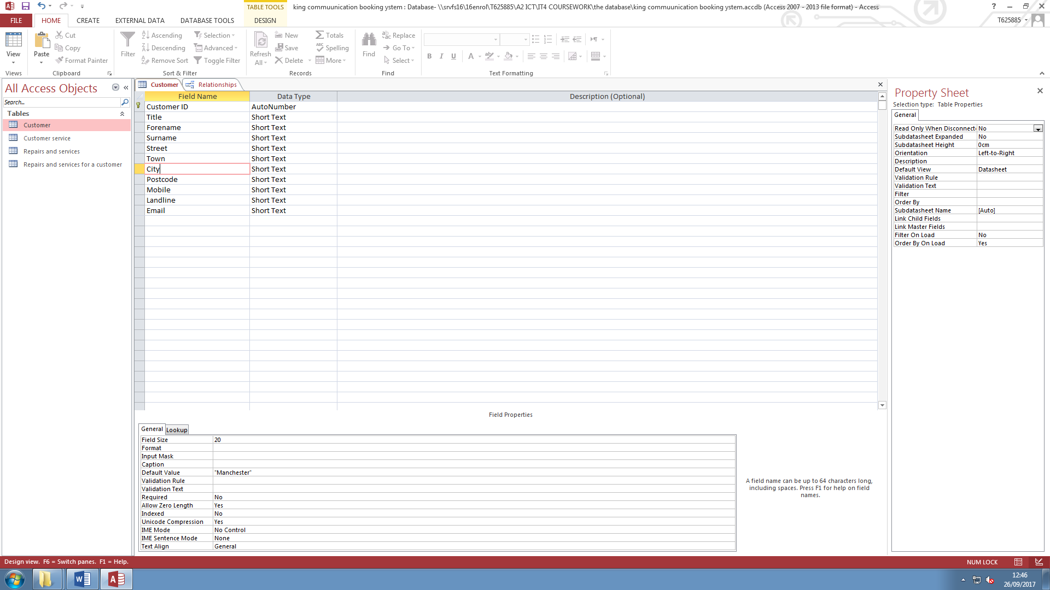

In the city field I set the default value to ‘Manchester’ because almost all my customer are coming from Manchester, because the shop is in Ashton.

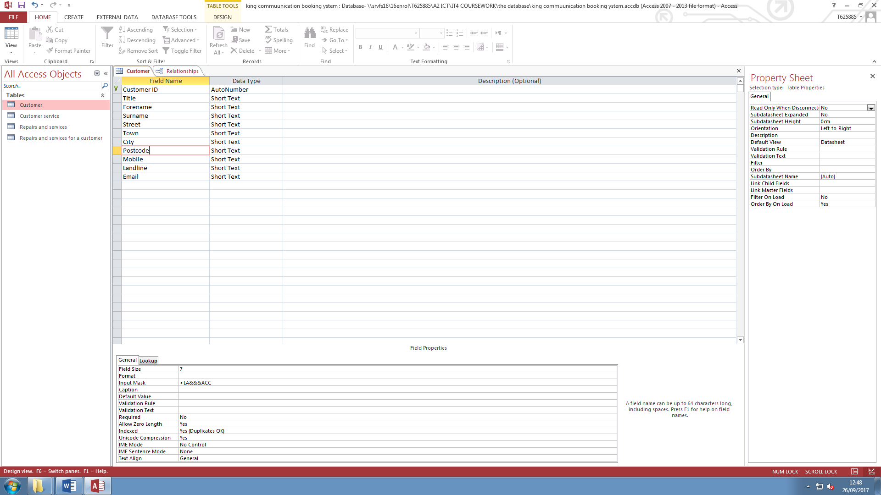

This is the postcode field and I have limited the size to only 7. I did this post code have the size of 6 or 7 and no bigger. This makes it easy to input data because it can catch a postcode that has more than 7 characters or less than 6 characters.

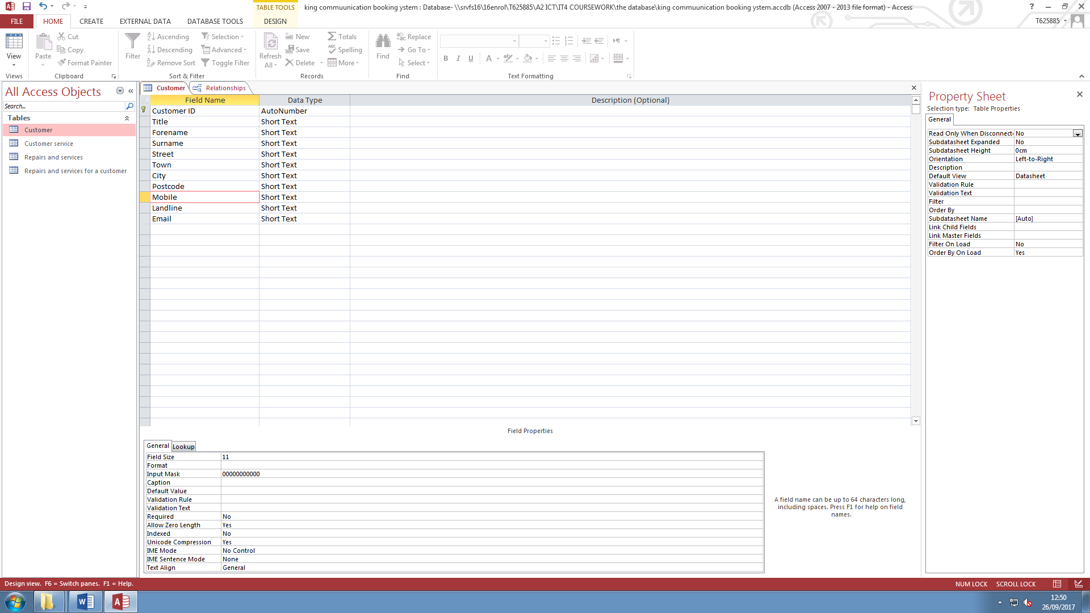

In the mobile number and landline number field I have limited the field size to 11. I did this because no mobile numbers or landline number get longer than 11 digits. I have used the mask ‘00000000000’. I used the ‘0’ character so that the user has to input 11 digits.

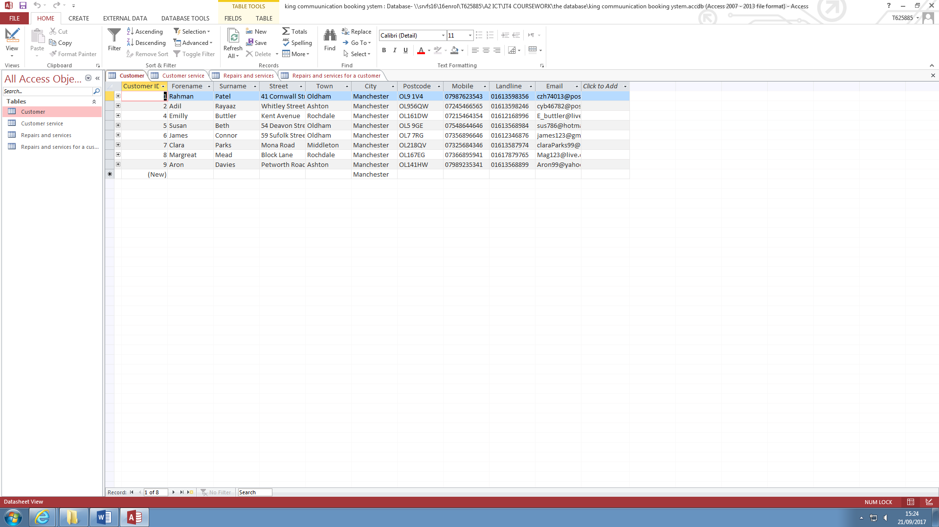

This is the table with all the masks and validation rules applied to it.

**Table 2 –Customer Service**

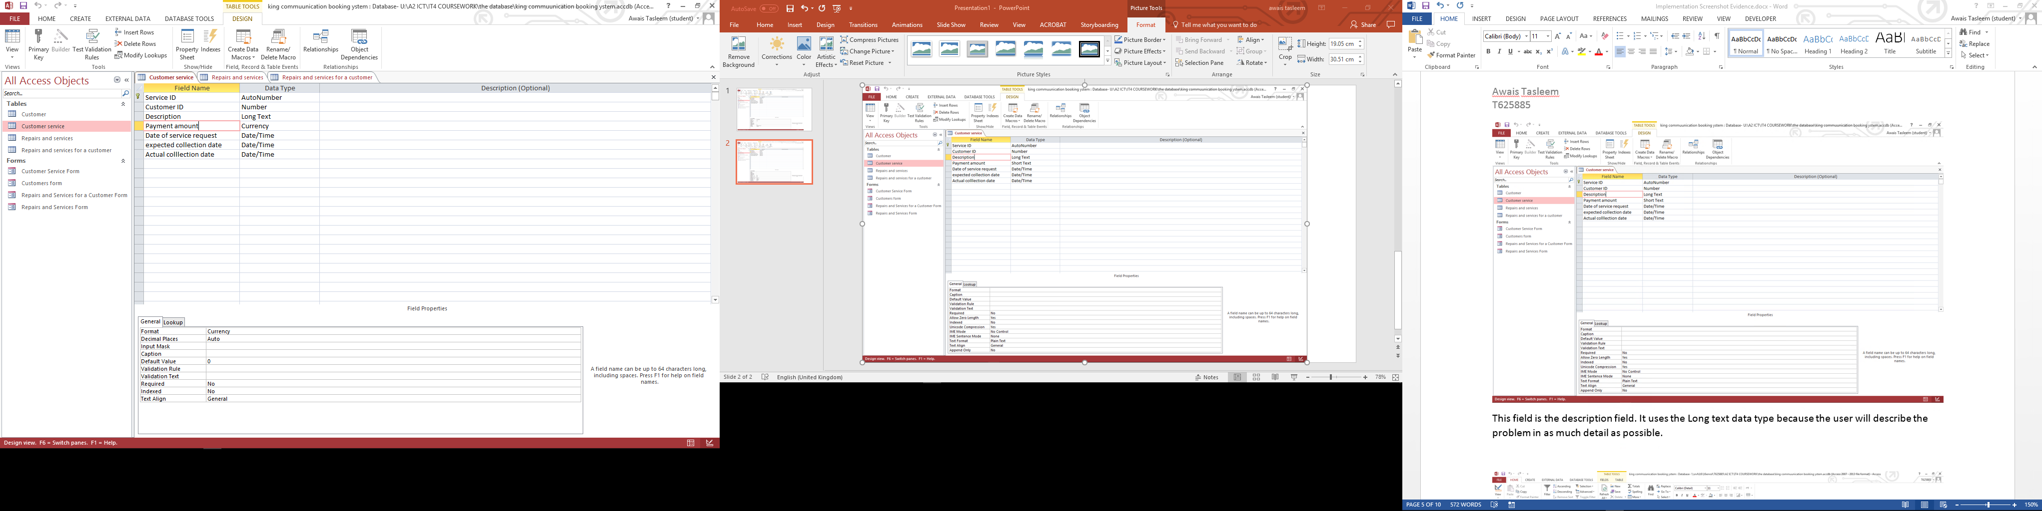

This is the customer service table with all the fields done. I set the Service ID to auto number, so that the number is generated automatically. This saves me time in entering a new number for every service done.



This is the customer id field. I have done a look up to the customers table because it is a foreign key, it’s a field from the customers table. I did this so that it makes getting customers details, quick and easy, and it will also make sure that data is only entered once because the tables are linked and the user can’t change the details of a customer in this table.



This field is the description field. It uses the Long text data type because the user will describe the problem in as much detail as possible.



Tin this field the user will input the cost of the service. I have set the data type to currency so that it will show up in pounds and pence’s.



The next 3 fields are about dates, this is why I have set the data types to Date/Time. I have set them to short date.

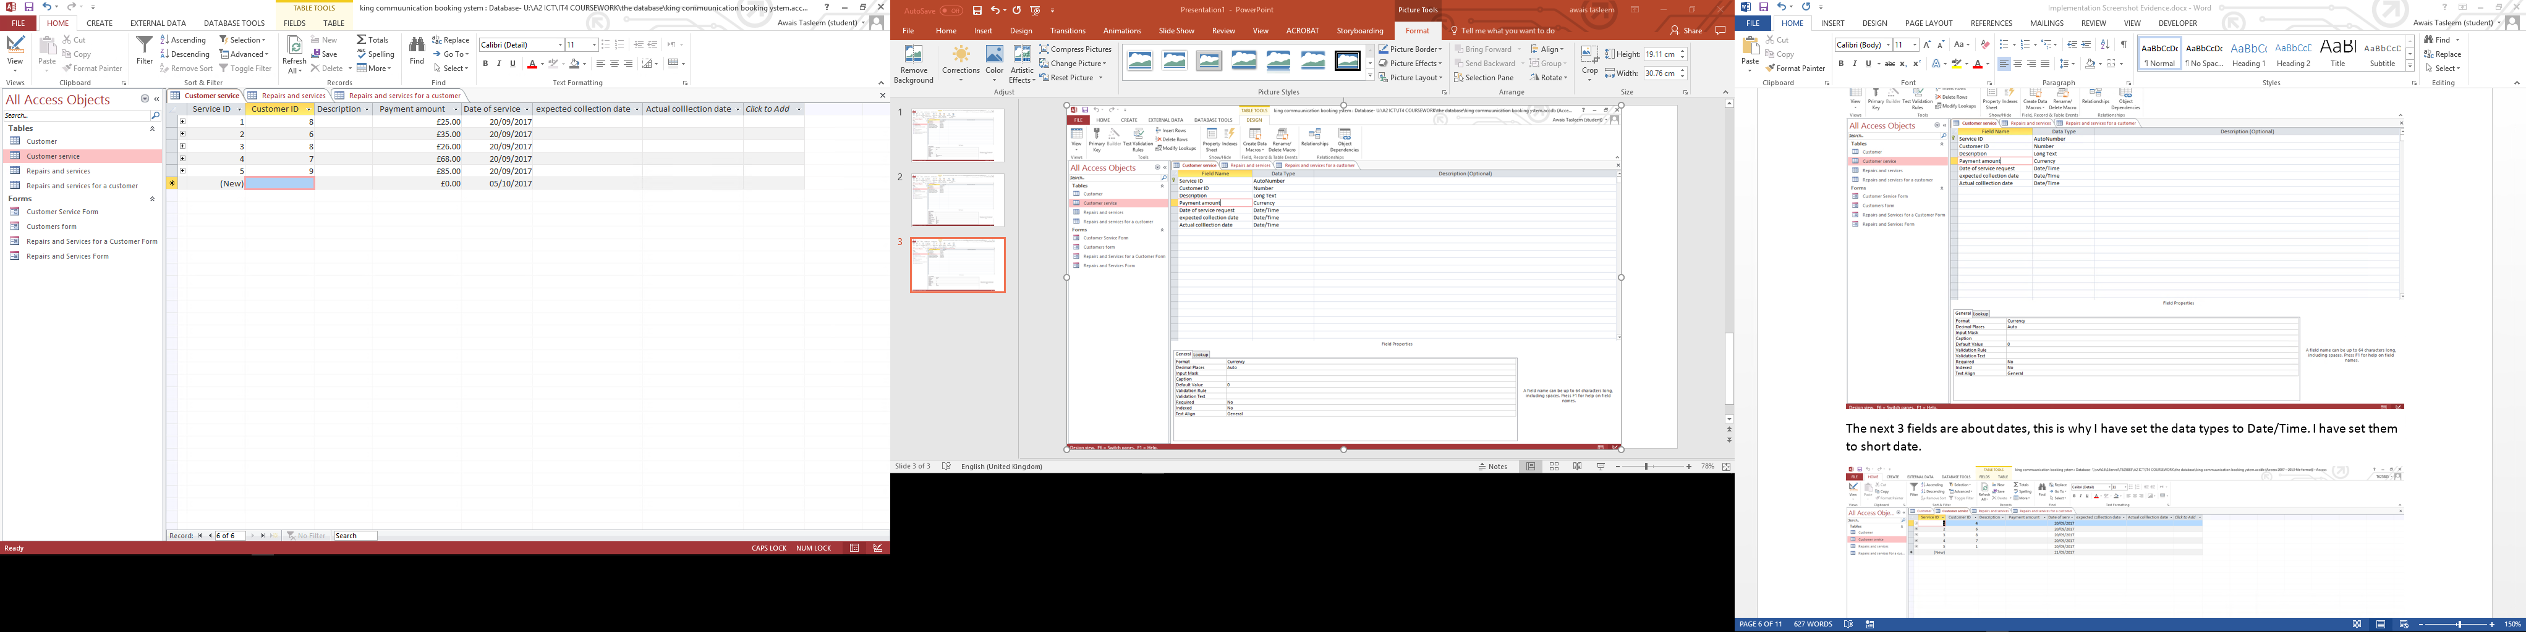

This is the table with some of the fields filled in.

**Table 3 Repairs and Services**

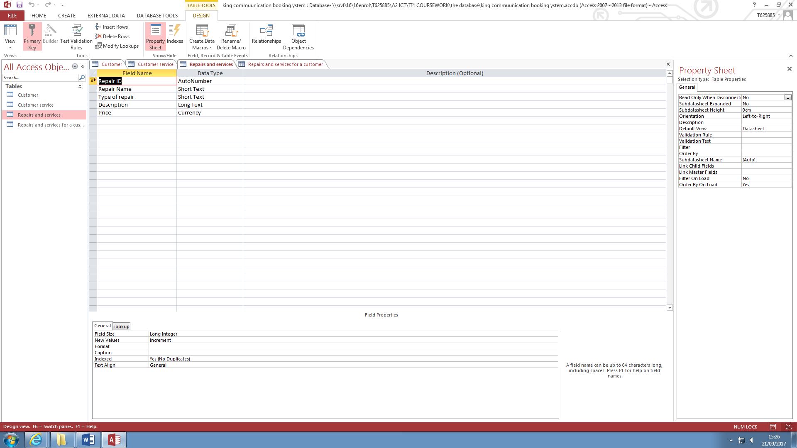

This is the repairs and services table. I have set the Repair ID to auto number so that it can automatically generate a new number saving time for the use.



I have set the second field called Repair name to short text because the name of the repair won’t be more than 6 maybe 7 words.



I also have a field called type of repair, this field will tell the user the basics of the repair, is it a screen replacement or a charging port fix. I have set this field to short text because it won’t use many words.

The description field is where the user will describe the repair or service. Used the long text data type because the user will need to describe the issue in detail.



The last field is the price field, it will contain the price of the repair. It uses the currency data type.

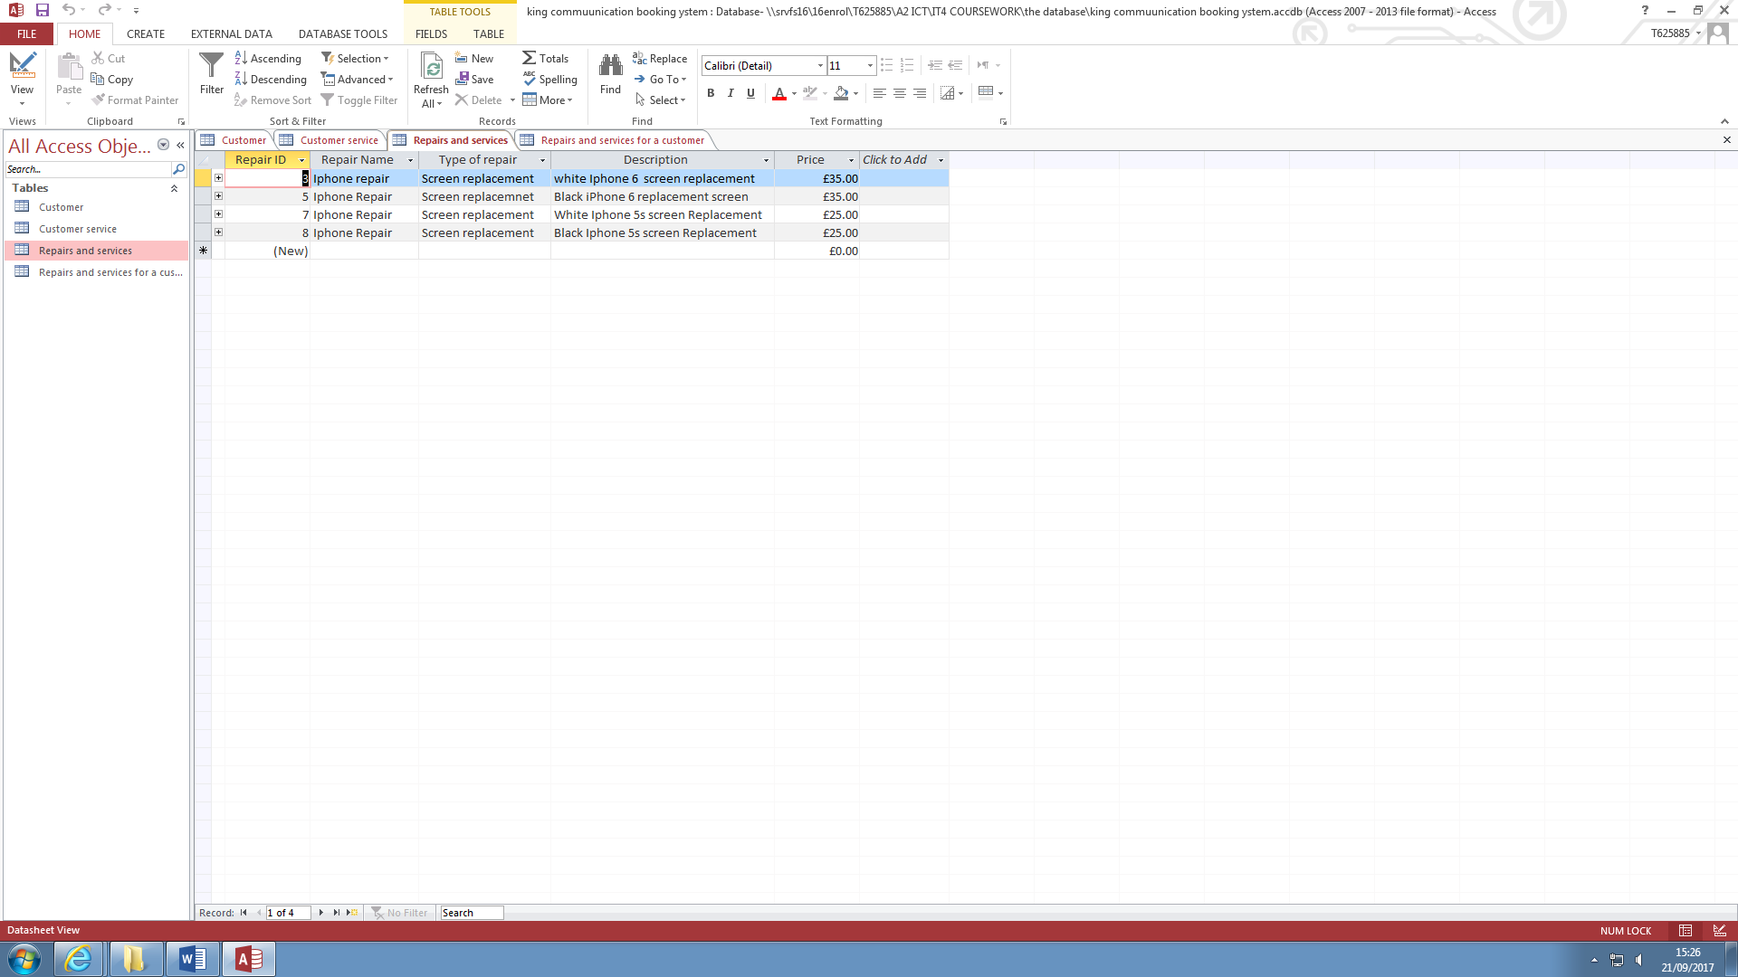

This is the table with most repairs and services inputted.

**Table 4 –Repairs and Services for Customer**

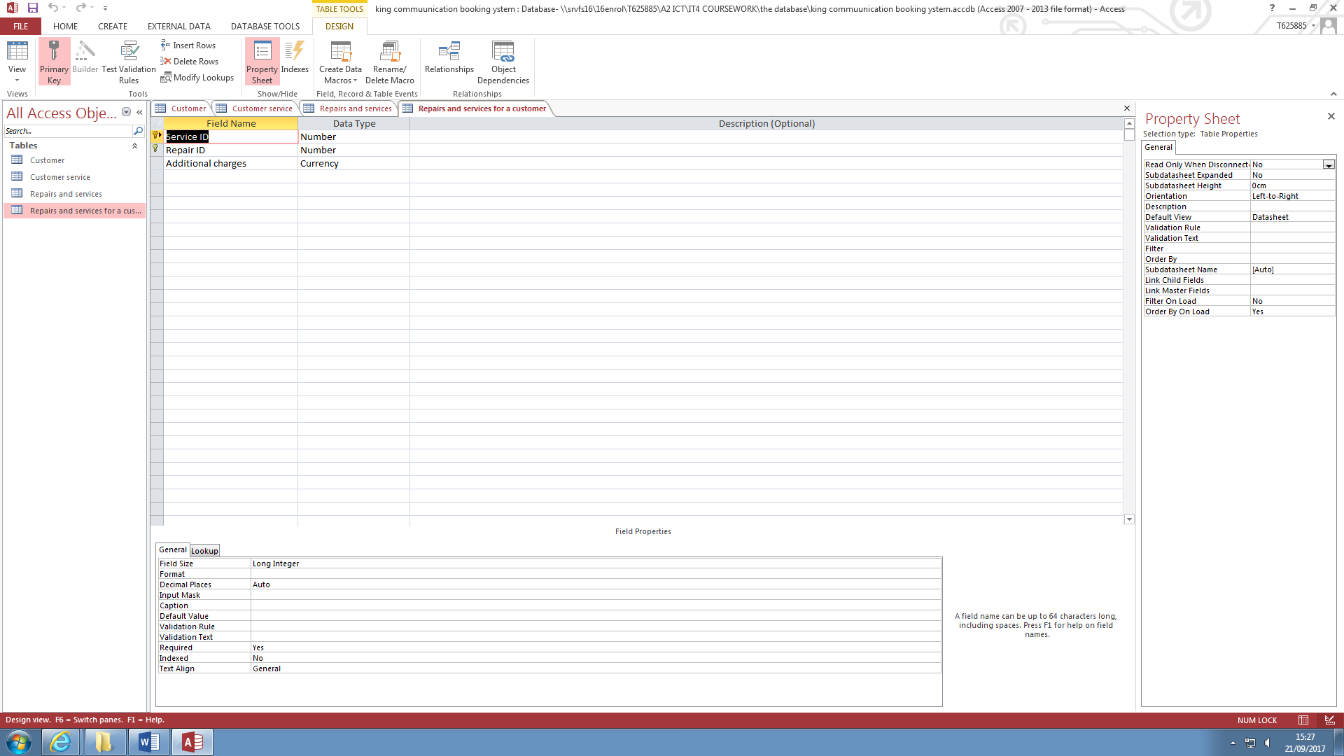

This is the repairs and services table for the customer. The first field is Service ID and is a foreign key from the services table. The second field Repair ID is also a foreign key from the Repairs and Services table. The last Field is the additional charges, and this uses the currency data type to have all the data inputted converted into a currency format.

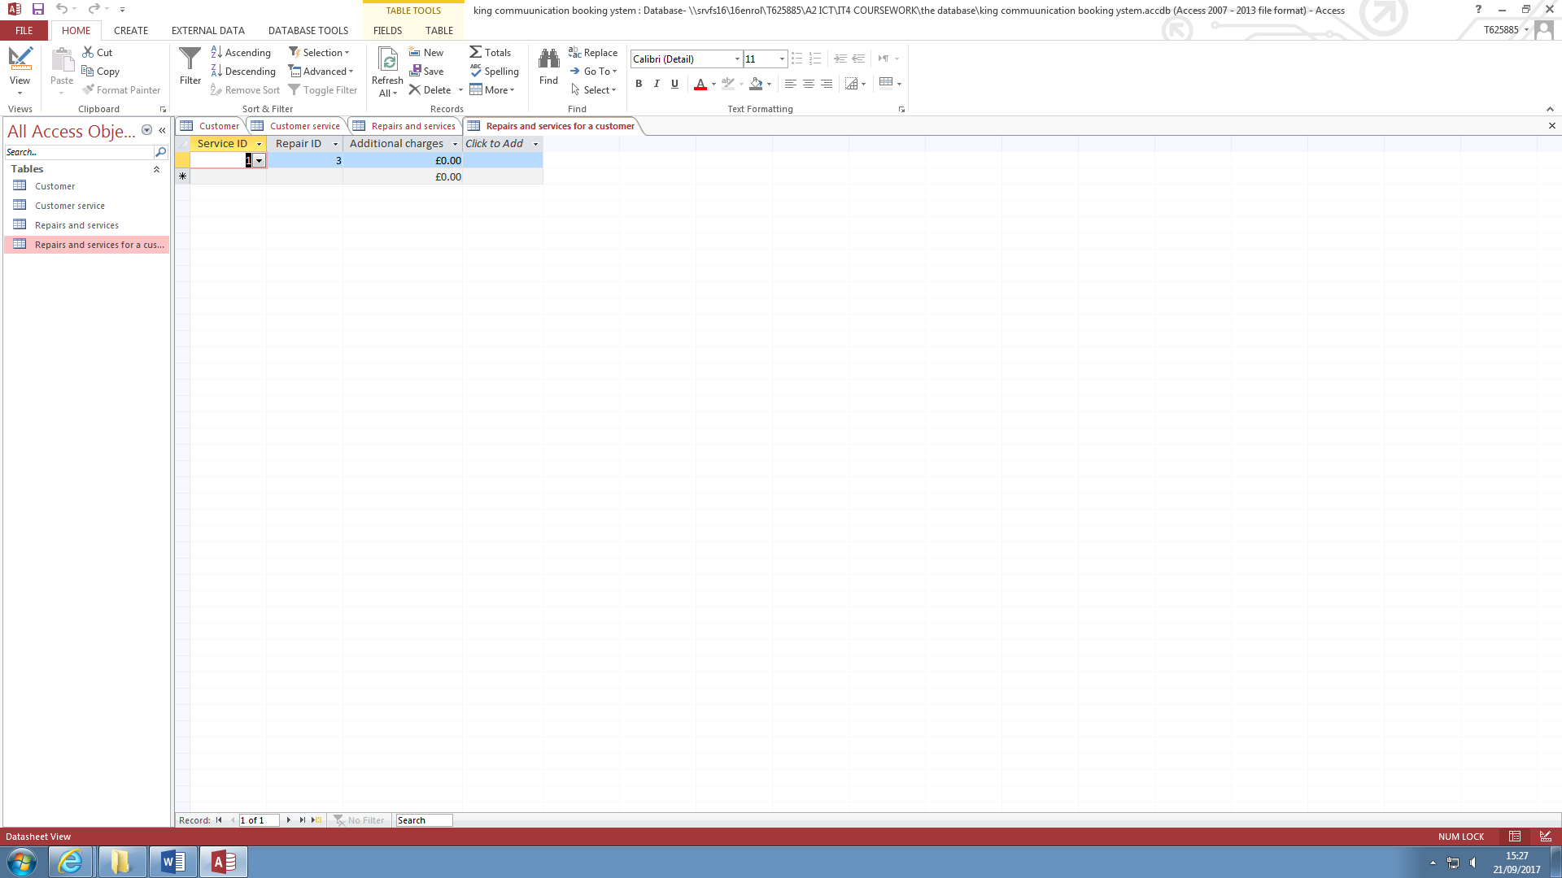

This is the table with all the fields selected.

**Relationships**

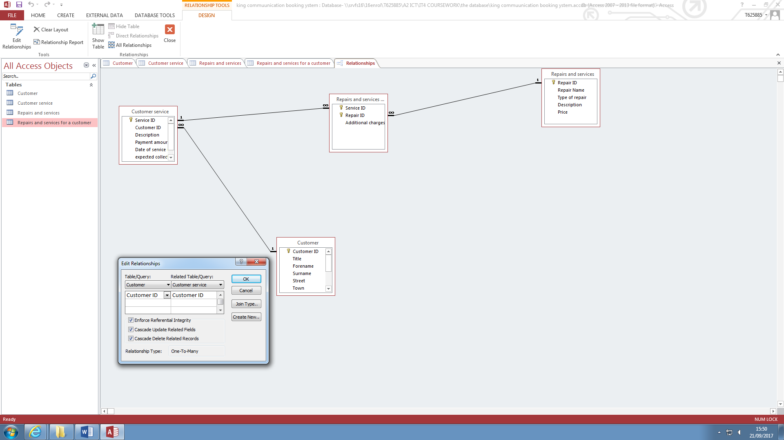

This screenshot show the relations ships between the tables. Each of the tables have a one to many relationship. I have linked all the tables in the correspondence of primary keys. I have ticked enforce referential, cascade update related fields and cascade delete related records. I did this so that another table can’t find a customer that isn’t in the customers table.

**Validation rule 1 - Range Check**

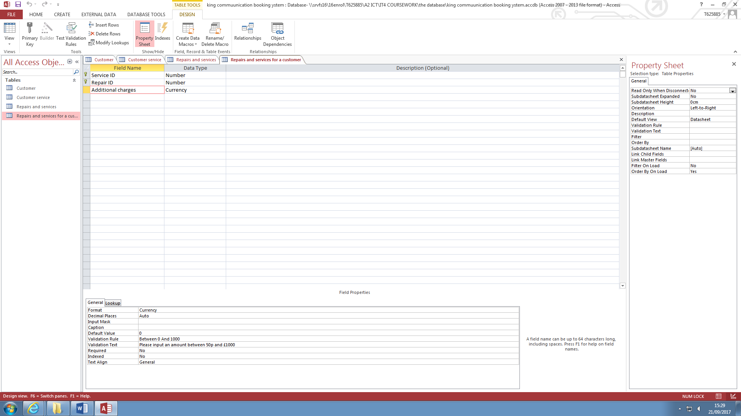

I have used a range check in the additional charges field. I did this so that there isn’t any inputting error in the table. This check will limit the amount the user can input. The limit is 0 and 1000.

**Validation rule 2 - Range check**

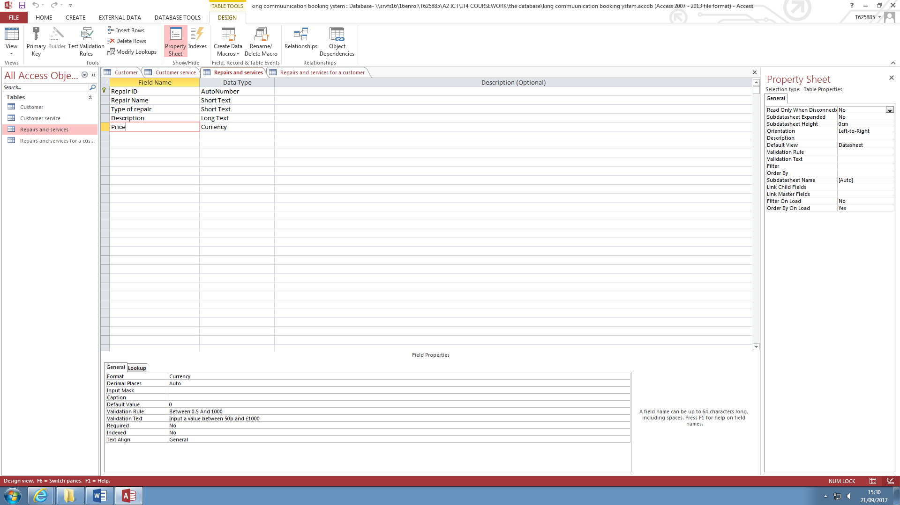

I have used another rage check in the 3rd table in the price field. I have limited the input range from 50p to £1000.

**Validation rule 3 - or**

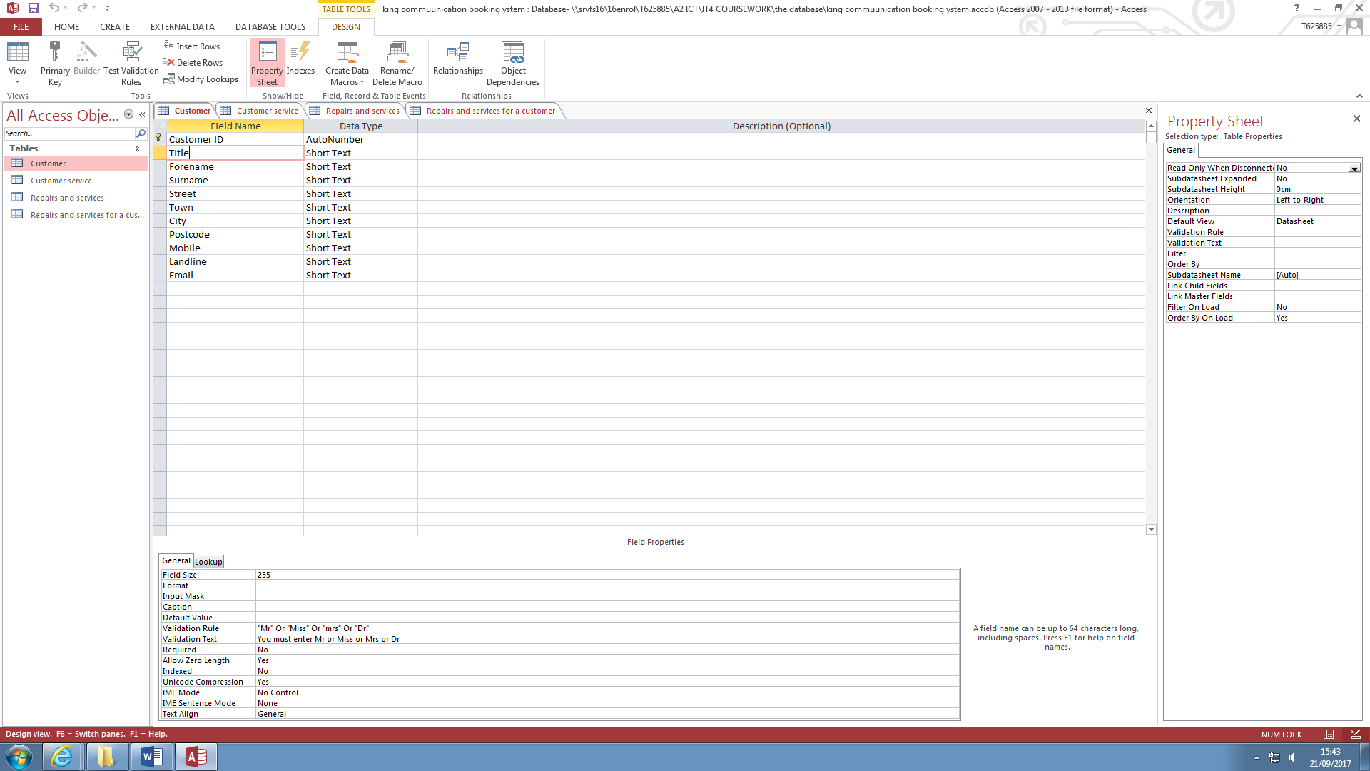

I have used the ‘or’ validation on the title field. This check that the user is only inputting a certain set of predefined characters, in this case Mr, Mrs, Miss or Dr.

**The welcome form**

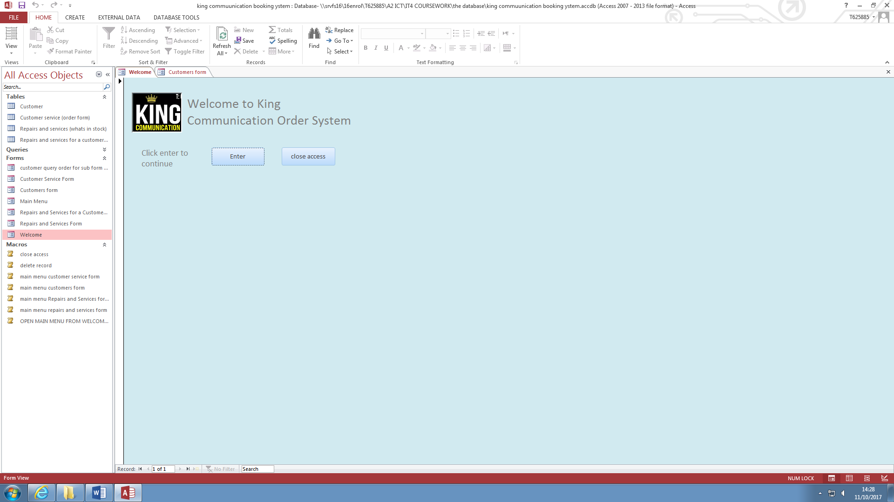

This is the welcome form, and I have set the background colour to light blue because it is calming to the eyes and causes less RSI to the user. When the user clicks on the Enter button, the main menu form opens and the Welcome form closes.

**The main menu form**

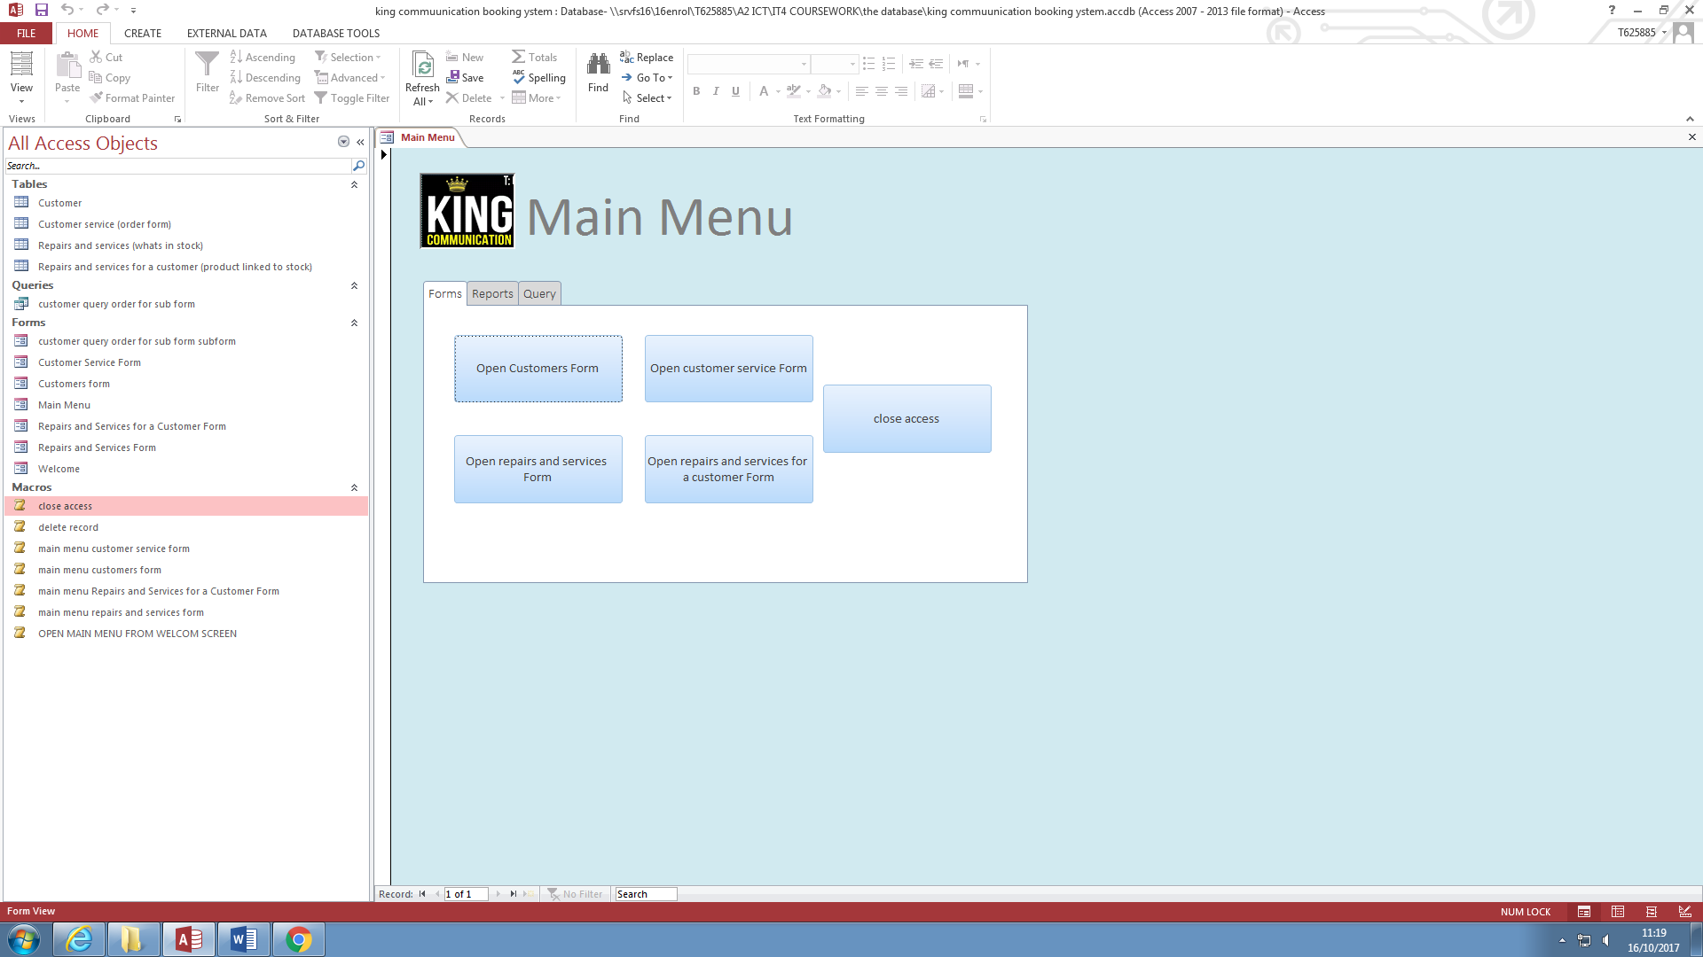

This is the main menu form. I have kept the same colour scheme and the design with the logo before the title of the form. Each button opens the corresponding form and closes the main menu form, so it does clutter the workspace for the user and make it confusing for them. I have also added a close access button so the user can quickly close the database.

**Macros 1 – Main menu Macro**

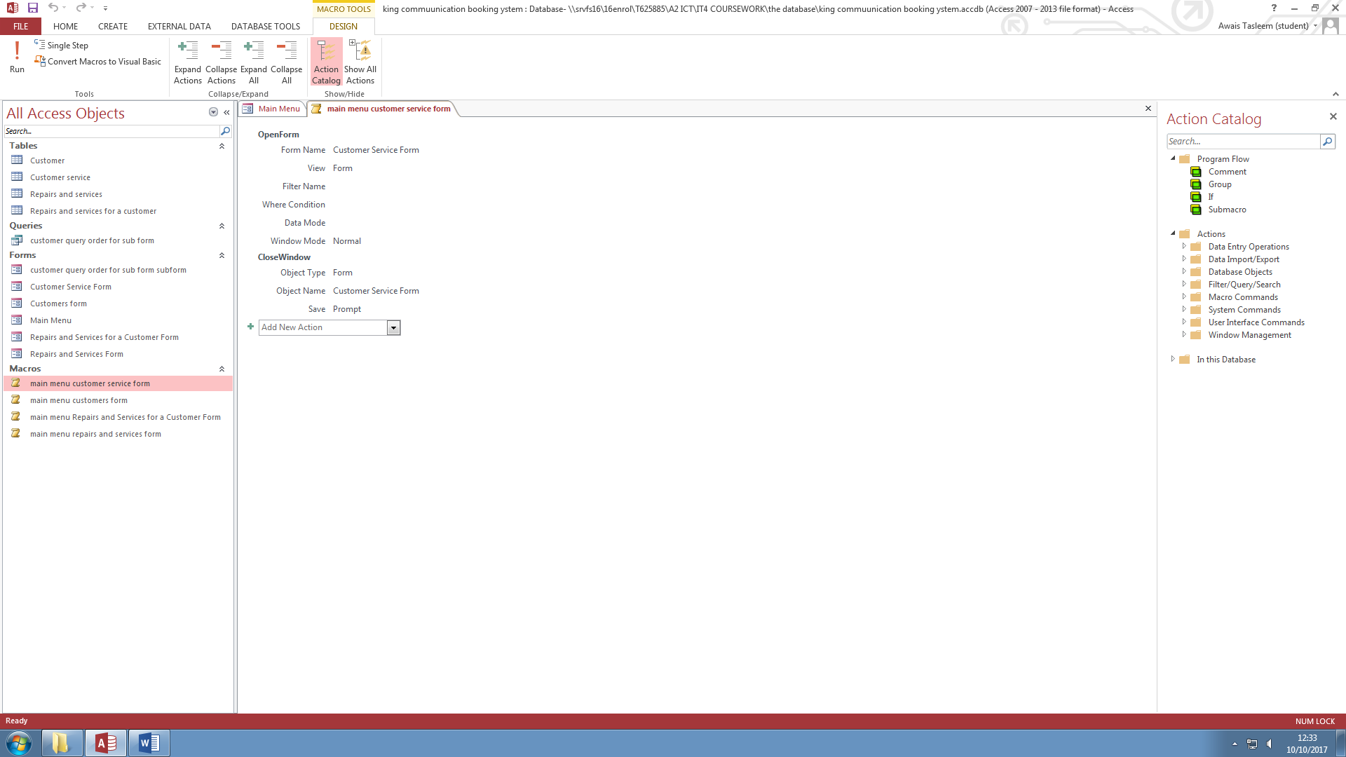

This is me making a macro that opens the main menu form and closes the current form that it is on. I used a macro so that the user can quickly navigate the forms.

**Macro 2 – Delete a record**

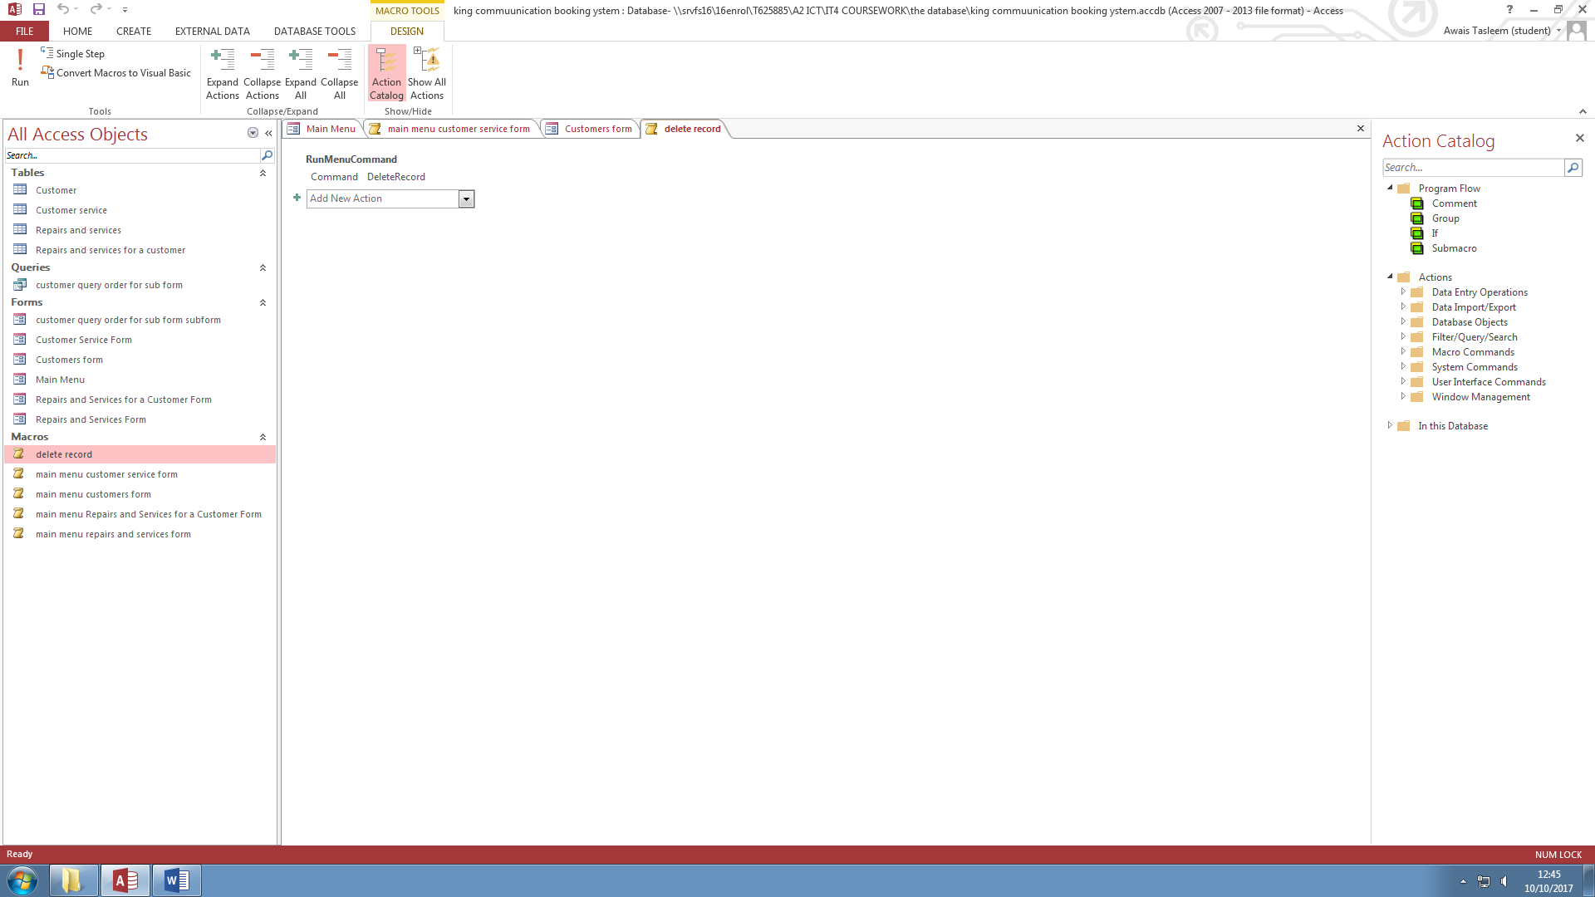

This macro will delete the record selected in the customers form. This makes adding and deleting customer easy for the user.

**Macro – 3 closing access**

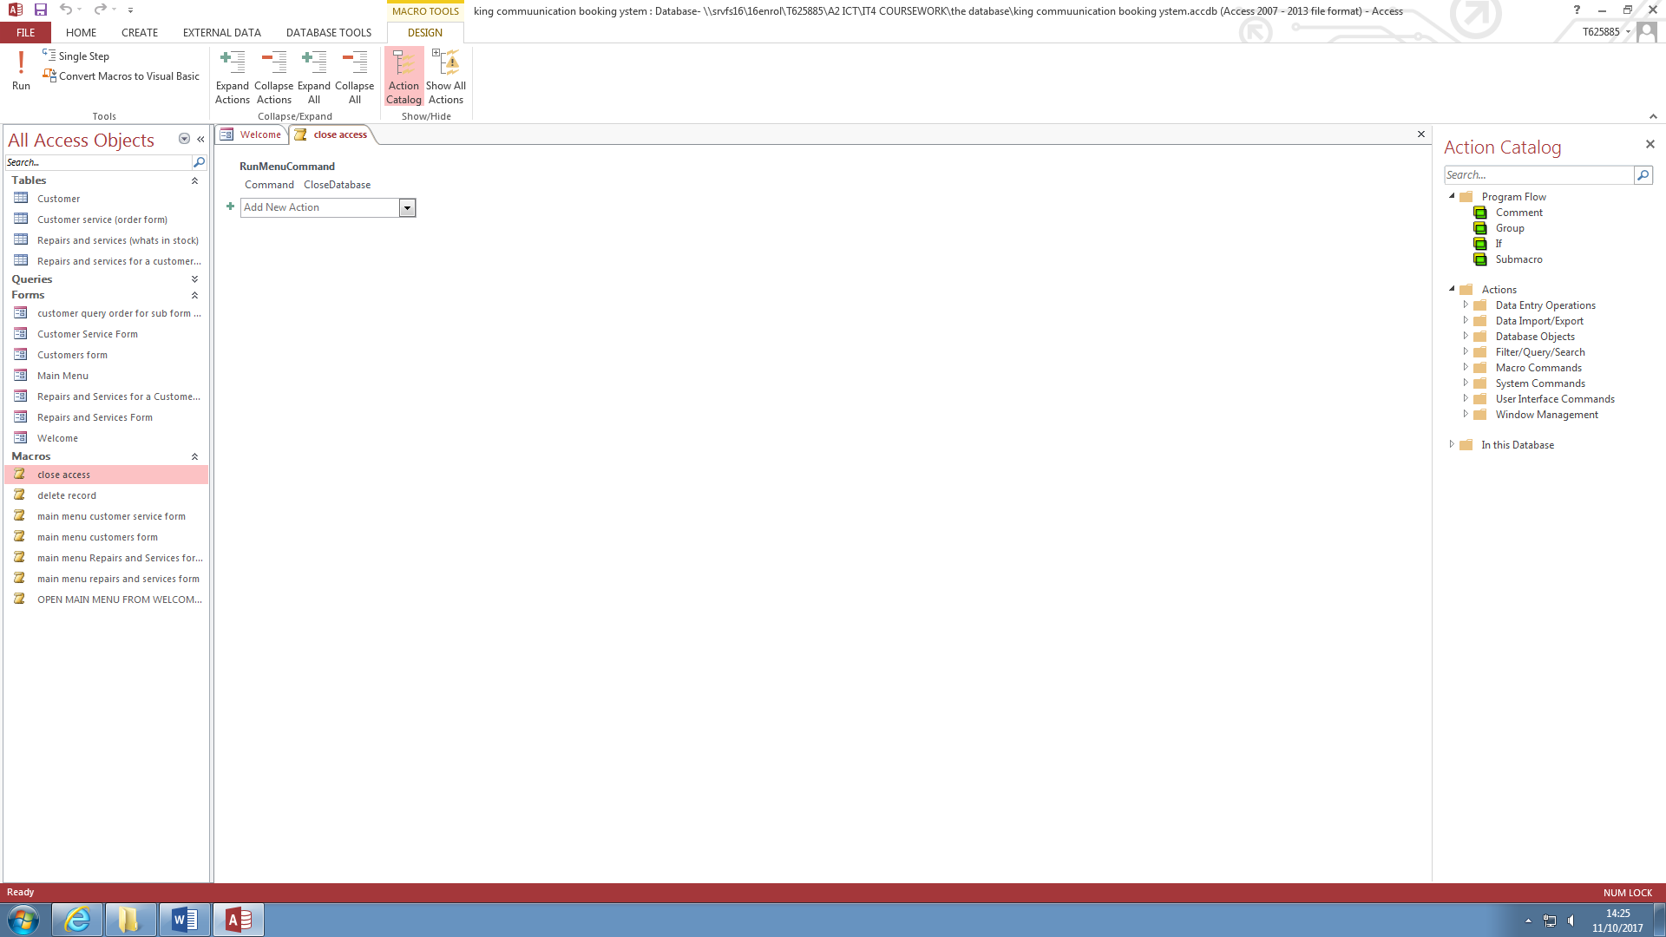

This closes the whole system. This macro is in the Welcome form and the user has an option to enter the system or to close it.

**Forms – Form 1 customers form**

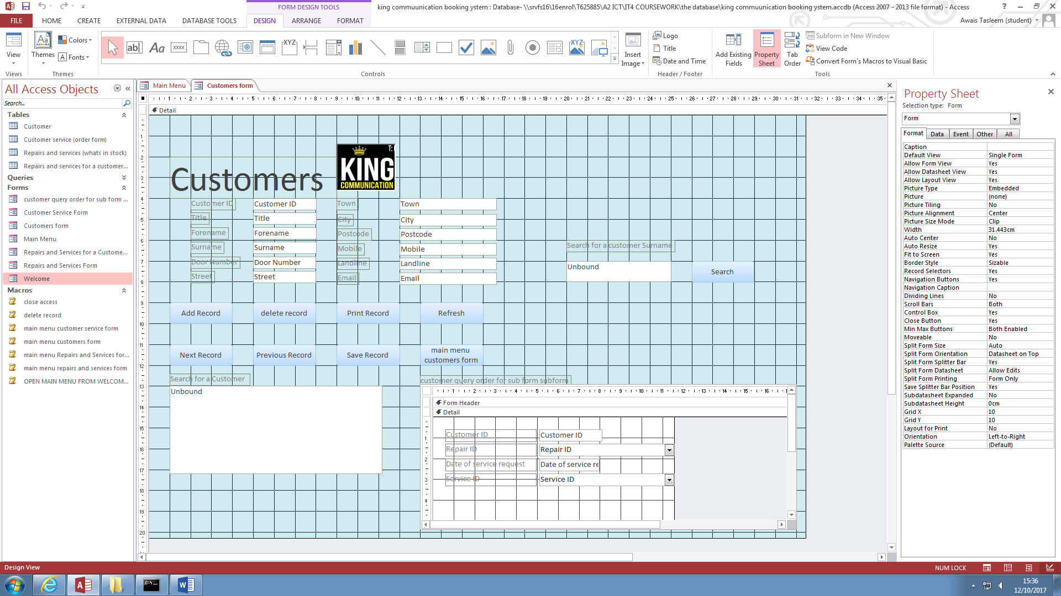

This is the design view of the Customers form showing all the properties in details. I have kept to the colour schme which is blue that I stated in the user requirments.

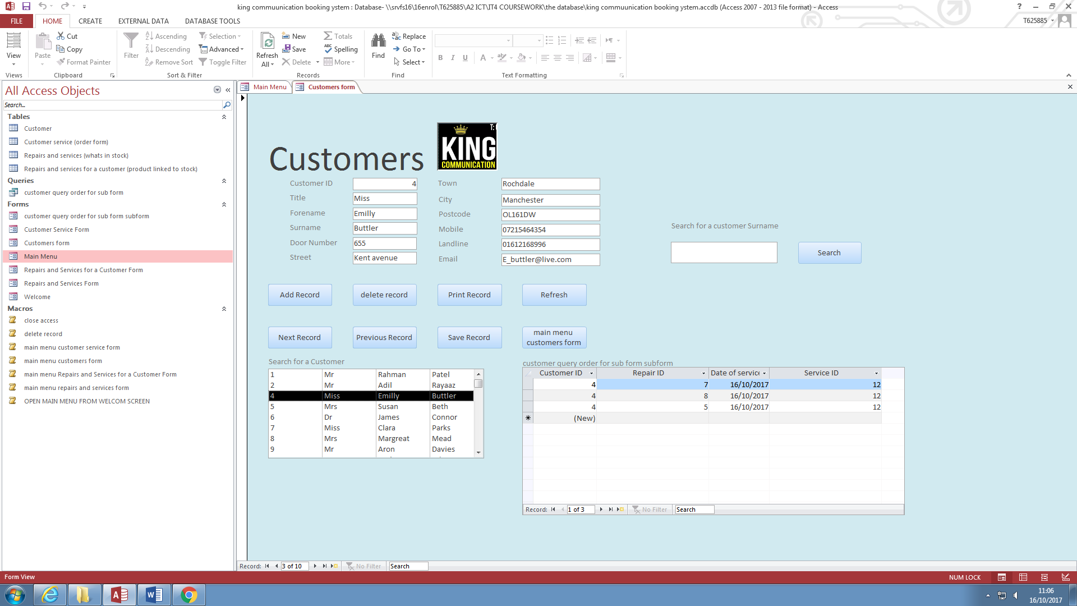

This is the customers form in form view. This is how the user will see the form. I have included a list box so that the user can easily select a customer. Within the form I have added9 buttons. One of these buttons is the search button and it searches for a customer by the user giving it a surname I used Visual basic coding to program the button. The other buttons that I have added are , Add record, Delete record, Print Record, Refresh, Next Record, Previous Record, Save Record, Main menu Customers from. I have also included a sub form that finds a customer’s past transactions and shows them to the user in the sub form.

**Form 2 – customer service form**

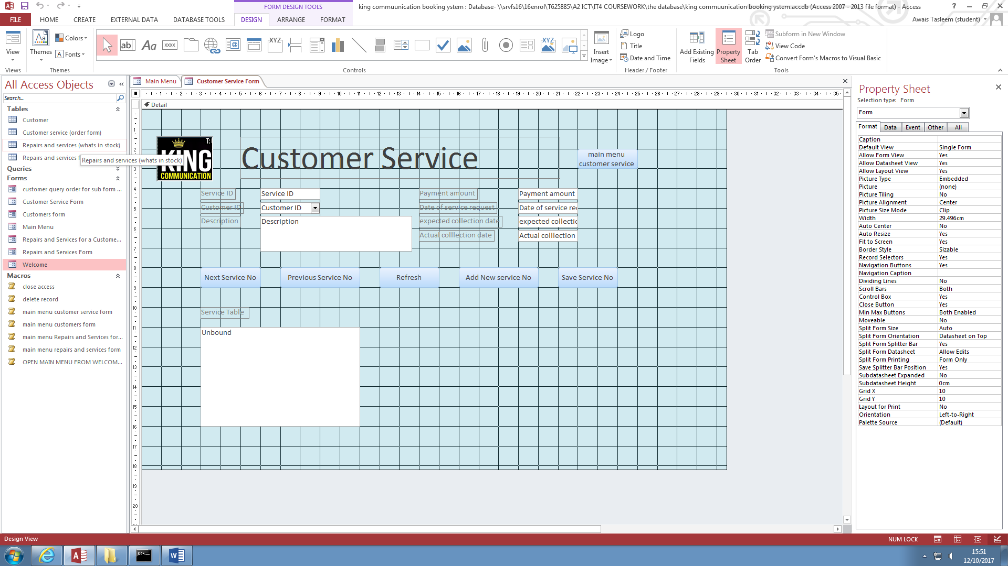

This is the design view of the customer service form.

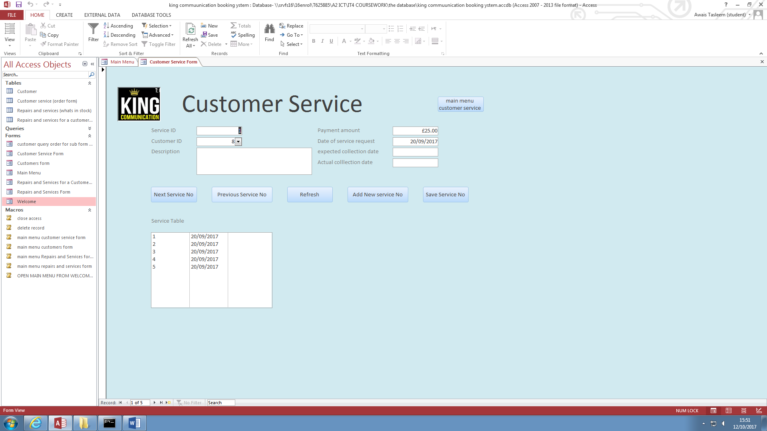

Reminder:

Make a sub form that shows the items being purchased with the total price.

This is the Customer service form in form view. It’s an order form that holds the customers items that they have purchased. I have used 6 buttons, these buttons are, Next Service No, Previous Service No, Refresh, Add Ne Service No, Save Service No and Main Menu.

**Form 3 – Repairs and Services form**

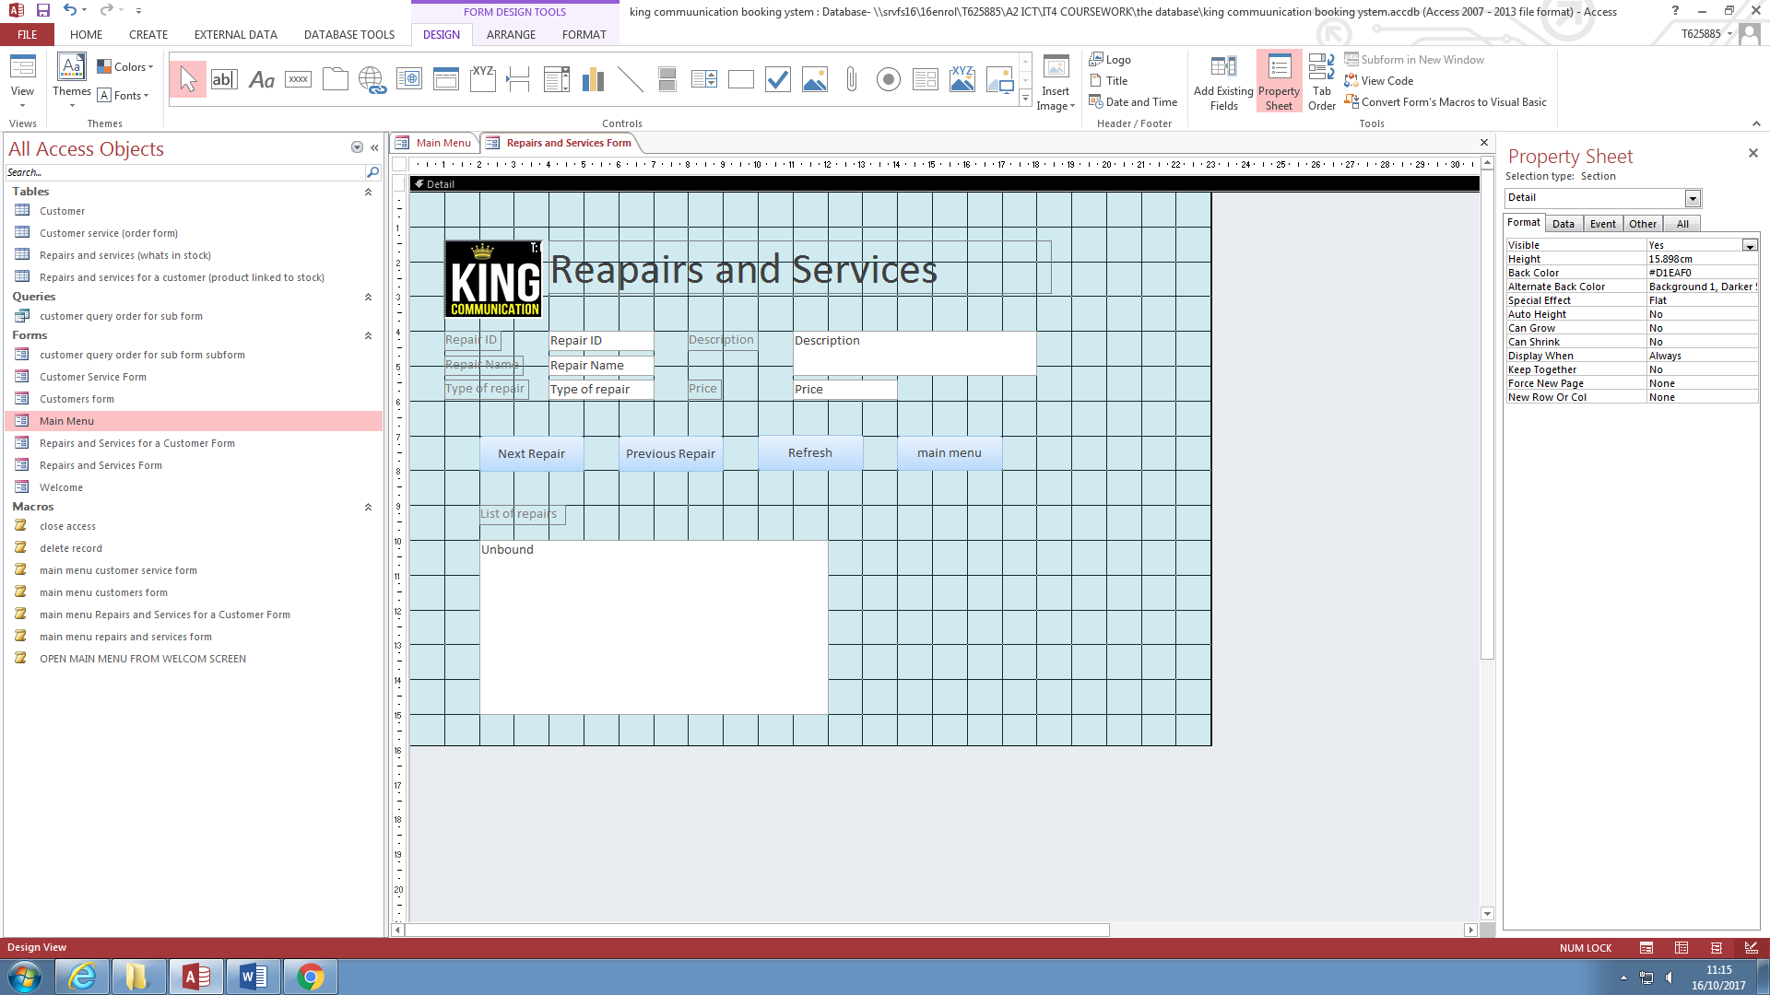

This is the repairs and services form in design view. 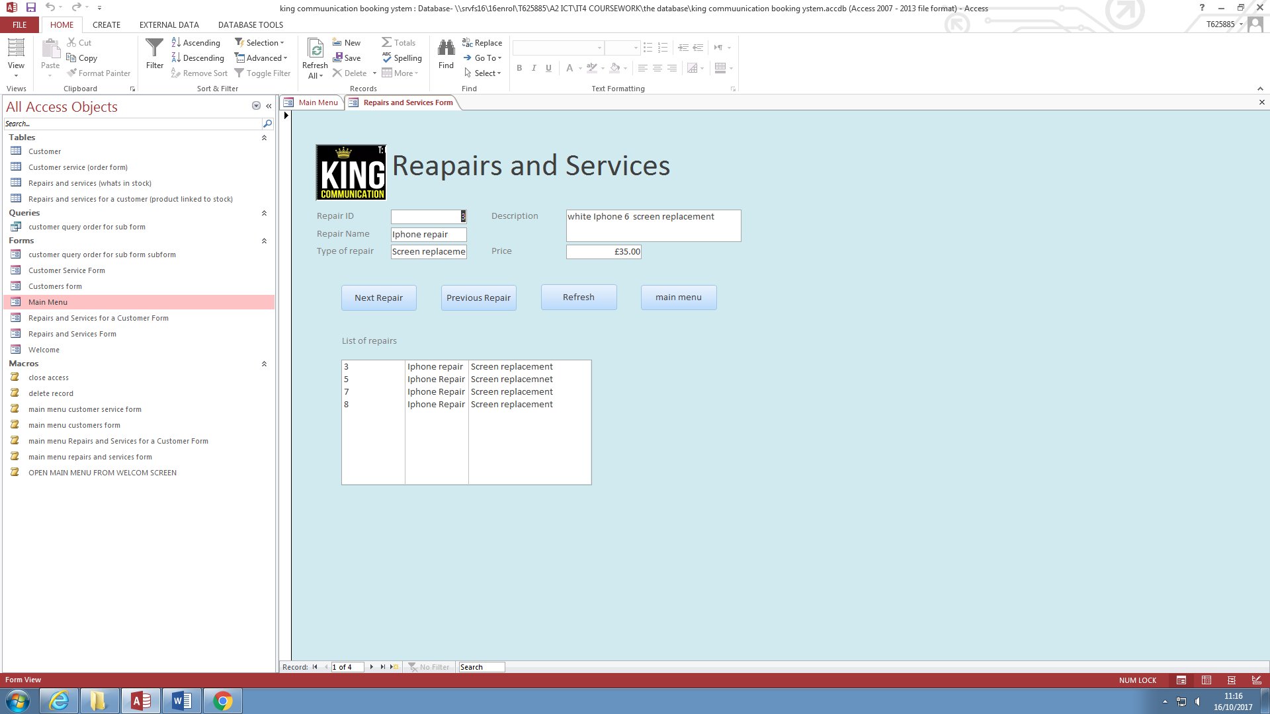

This is the repairs and services form. This form shows what repairs and service the shop has on offer so the user can easily and quickly select it. I have added 4 buttons, Next Repair, Previous Repair, Refresh and Main Menu.

**Sub Form - customer query order for sub form sub form**

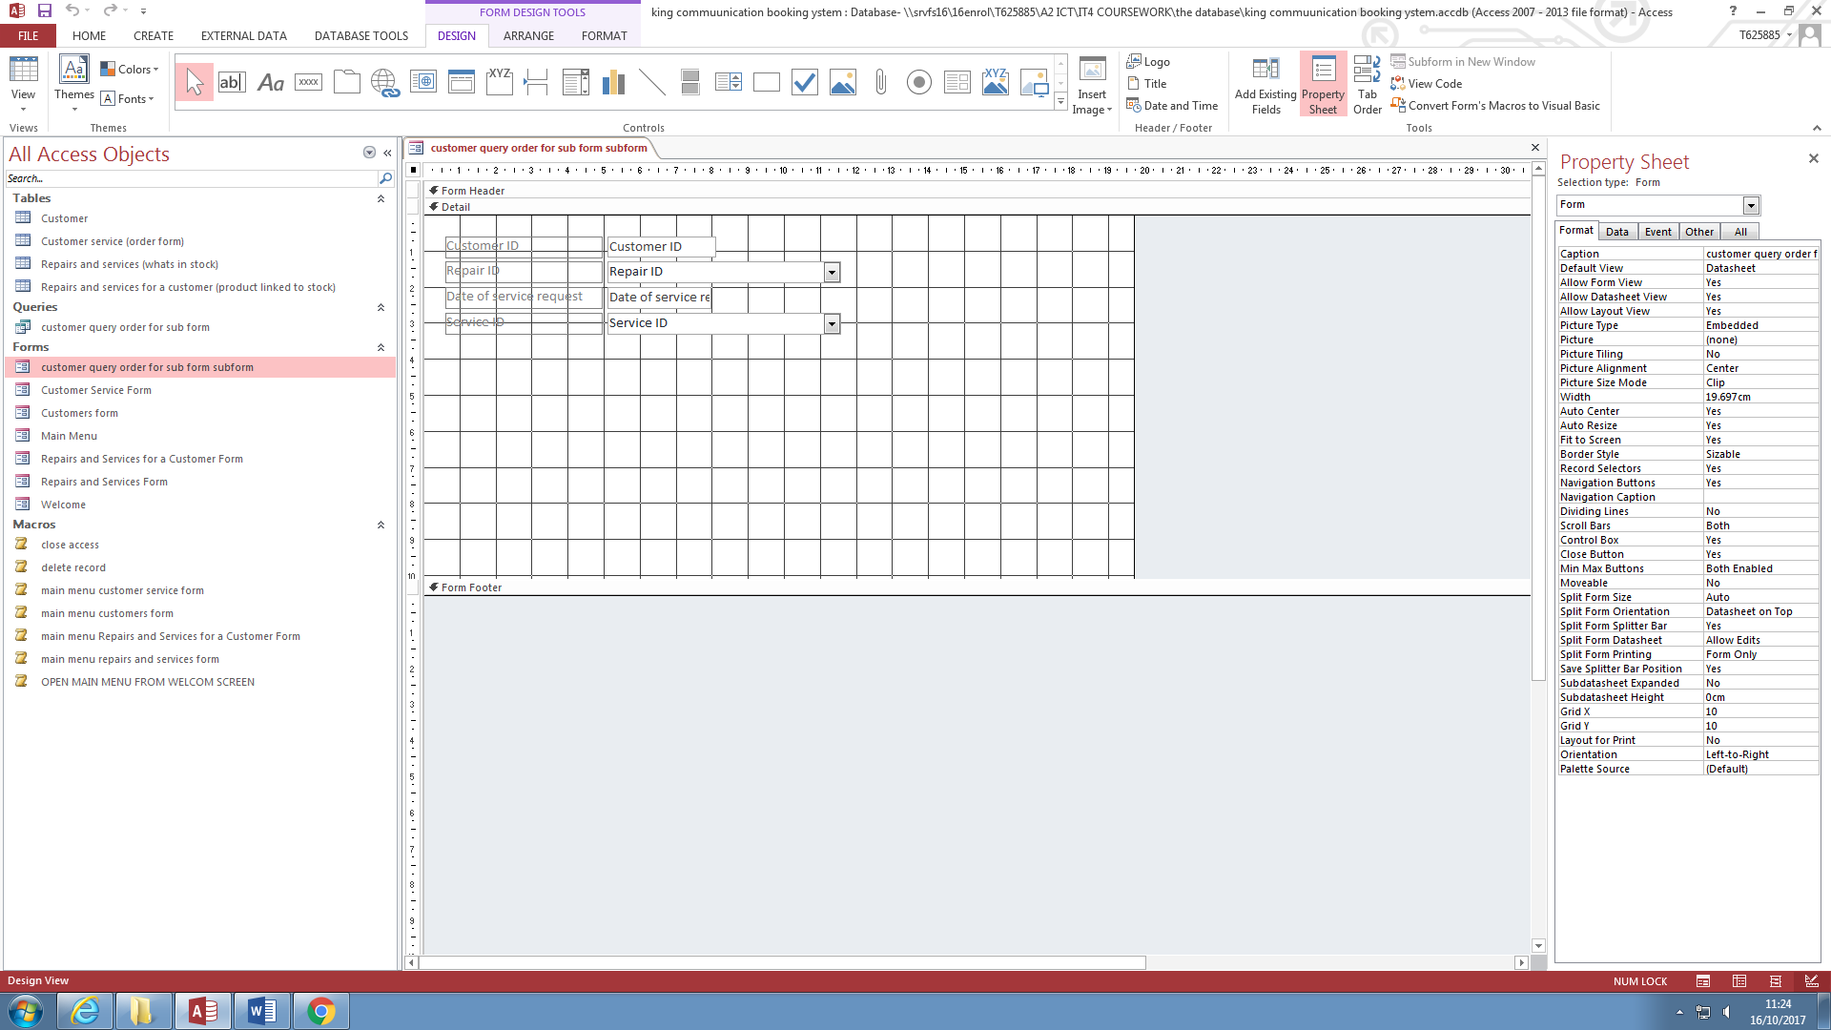

This is the design view of the sub form.

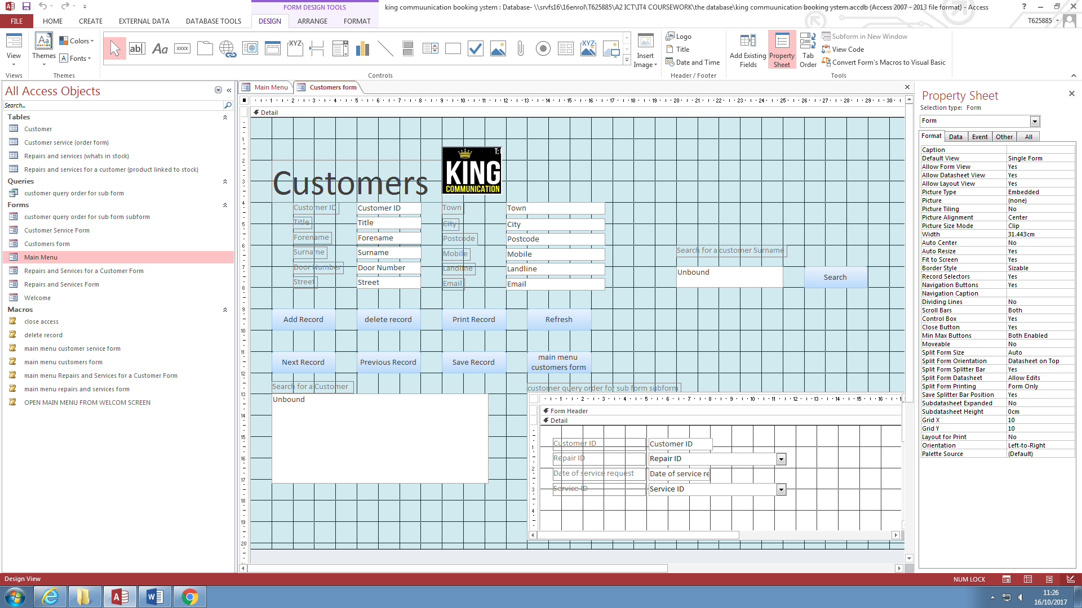

This is the sub form inserted in the Customers form. This sub form shows customers past orders.

**Queries**

**Query 1 – Single table – Search for a repair**

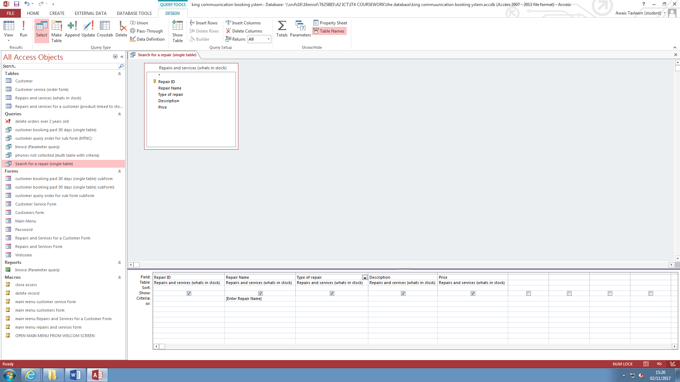

This is the query in design view. I am looking in the Repair and services table. This query will ask the user for a name of a repair and show if the is in the database. The criteria that I used was ‘{Enter Repair Name]’. This makes searching for repairs and services much quicker and it will save time.

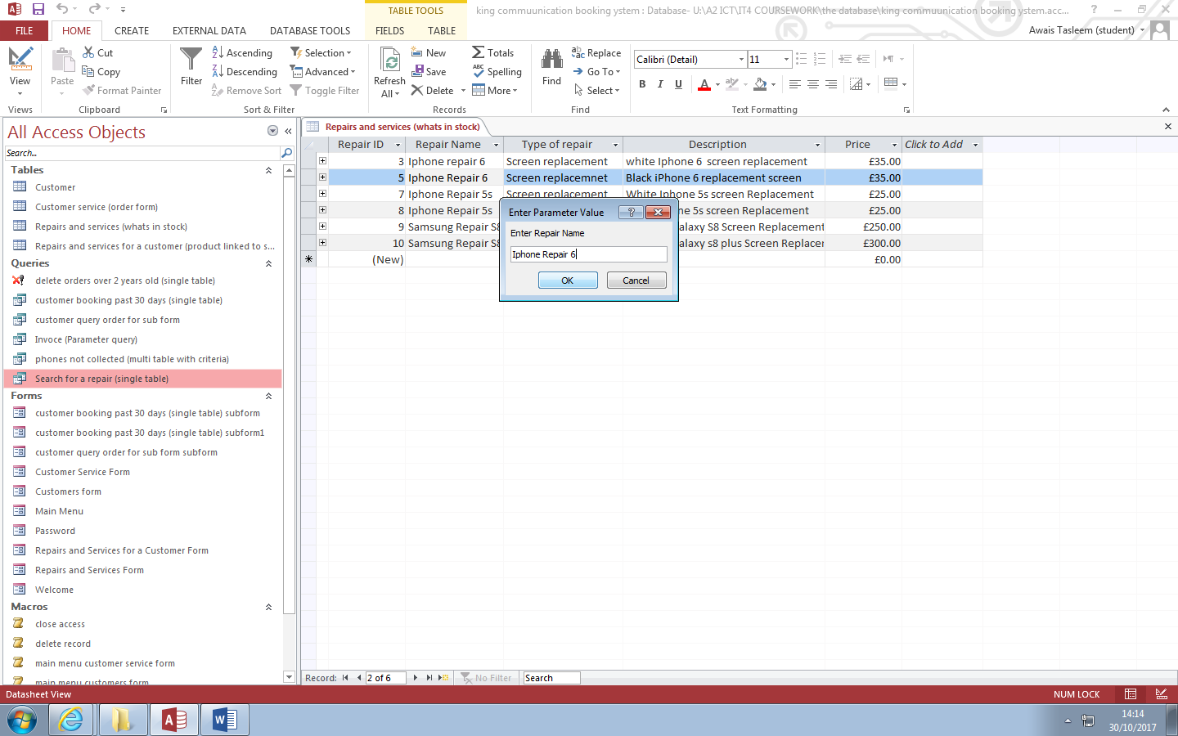

This is me inputting a name of a repair in the system to see if it’s in the database.

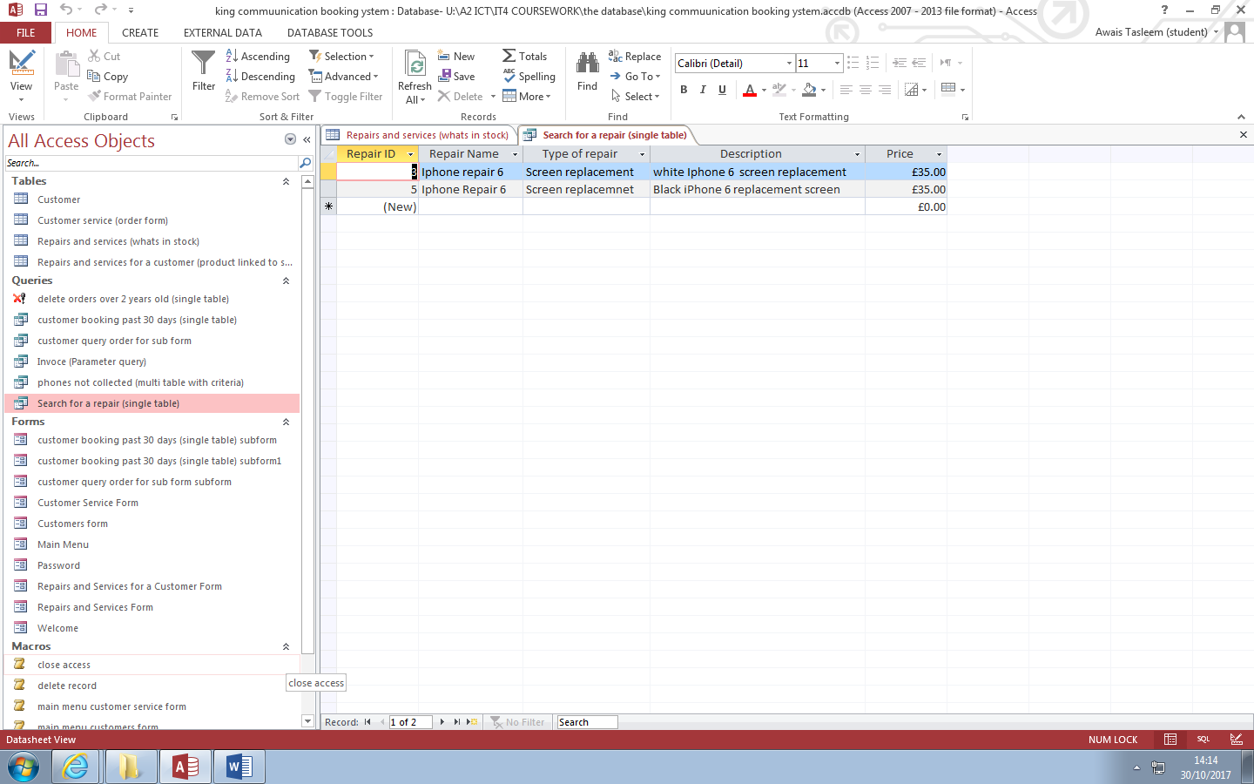

This is the table after it has found the repair.

**Query 2 – single table - customer booking past 30 days**

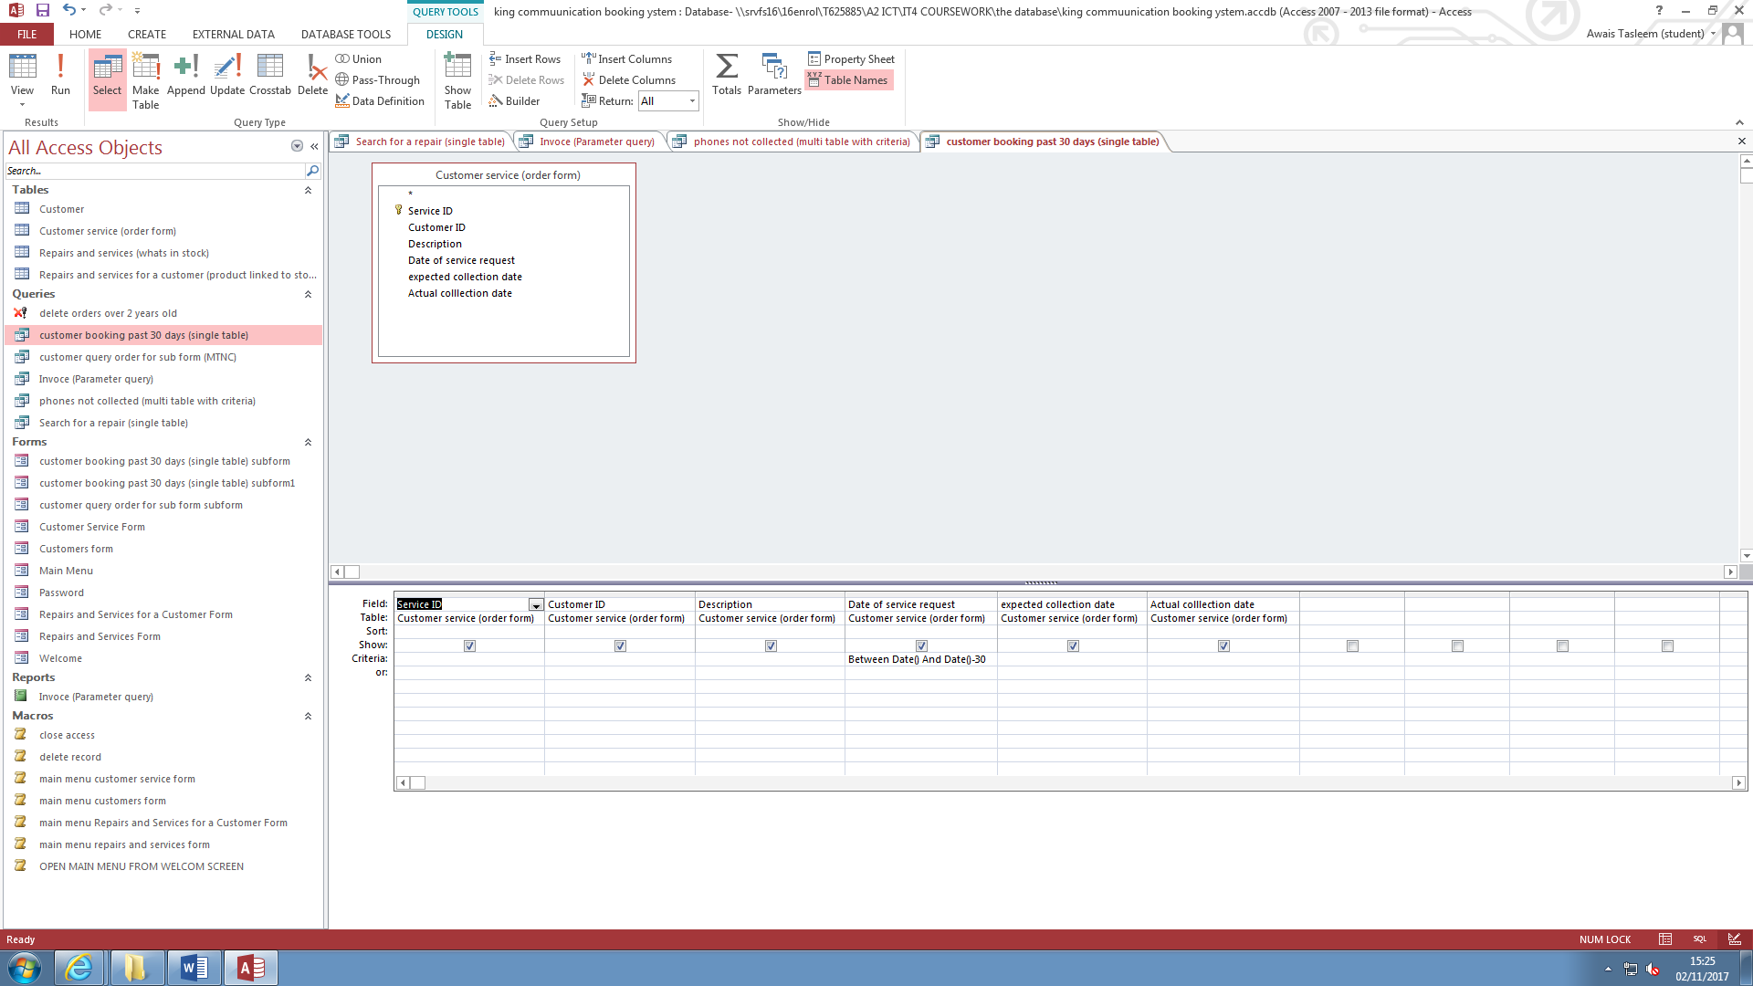

This is the design view of the customer booking past 30 days query. This query shows all the customers that have placed an order for a repair or service with us in the past month. I use the criteria ‘Between Date () and Date ()-30.

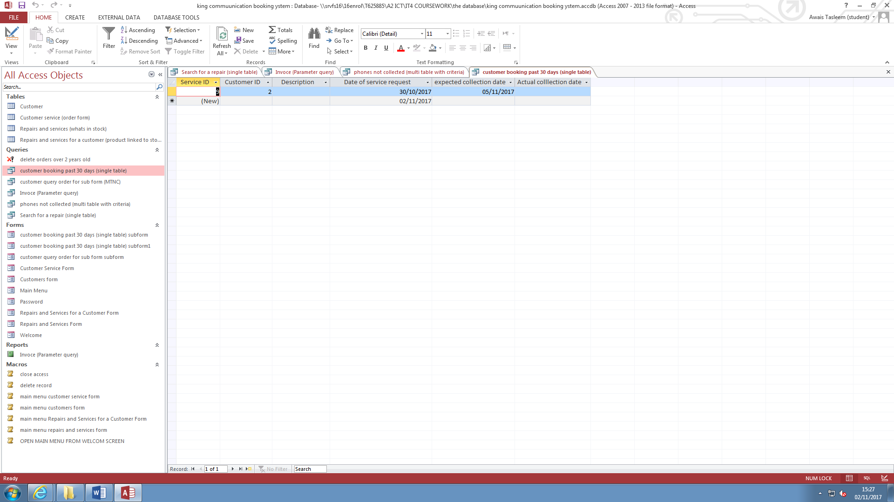

This is the query with all the orders from the previous month.

**Query 3 – Multi Table with Criteria**

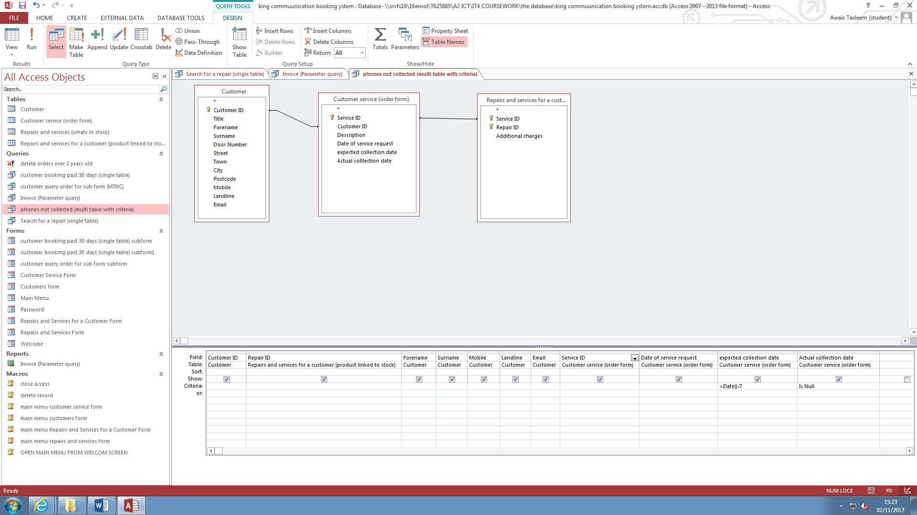

This is the phones not collected, multi table with criteria query. The criteria for the expected collected date is <Date () – 7. The criteria for the Actual collection date is ‘Is null’. This is any blanks in the table. These blanks are the items that haven’t been collected.

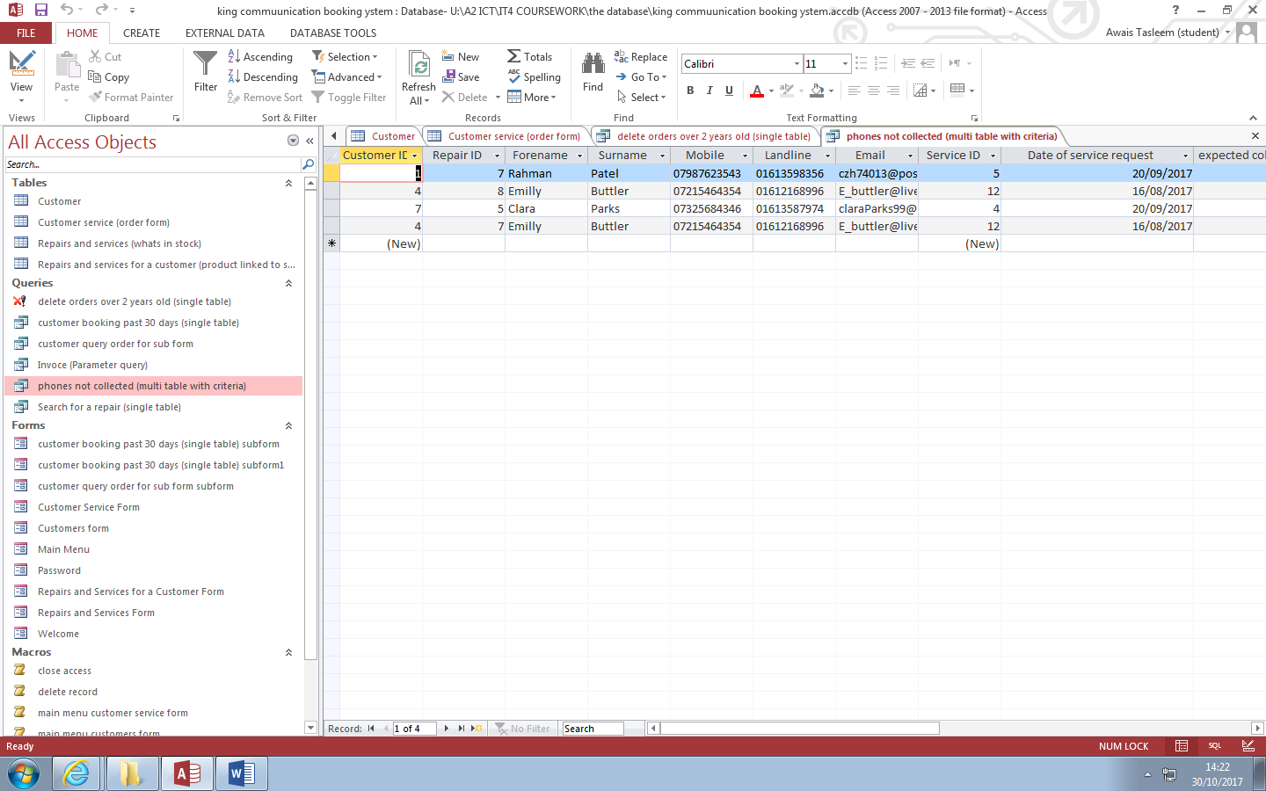

This is the completed query with all the non-collected orders.

**Query 4 – Parameter query – Invoice**

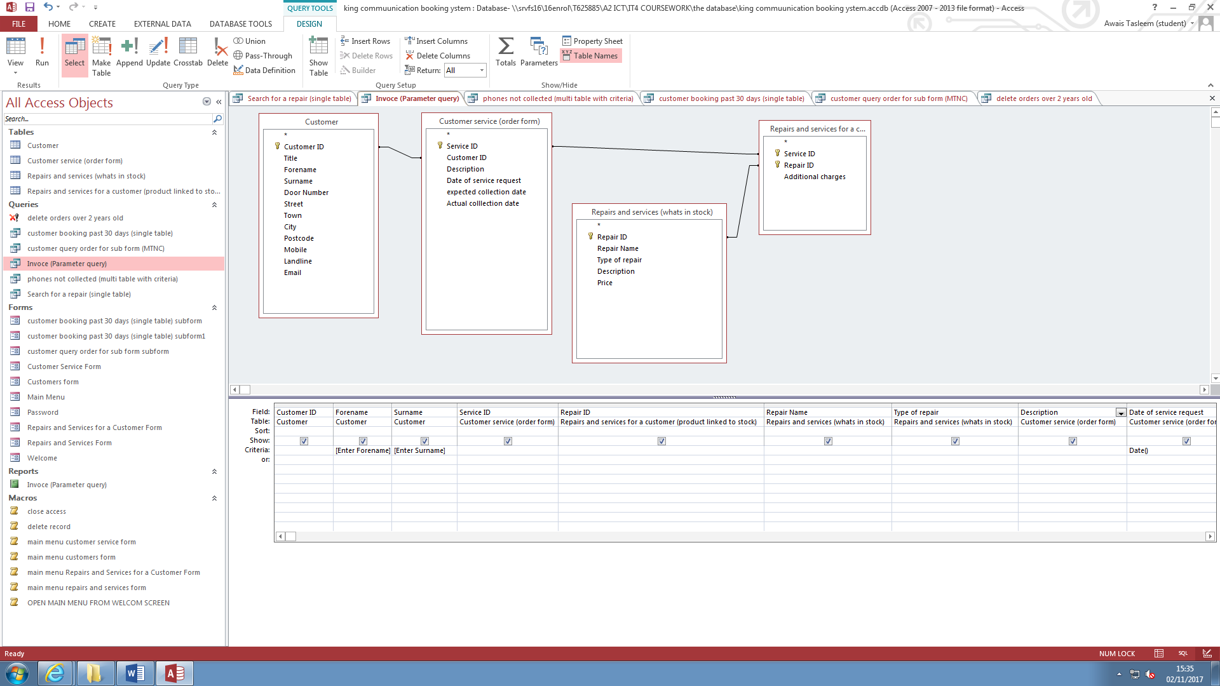

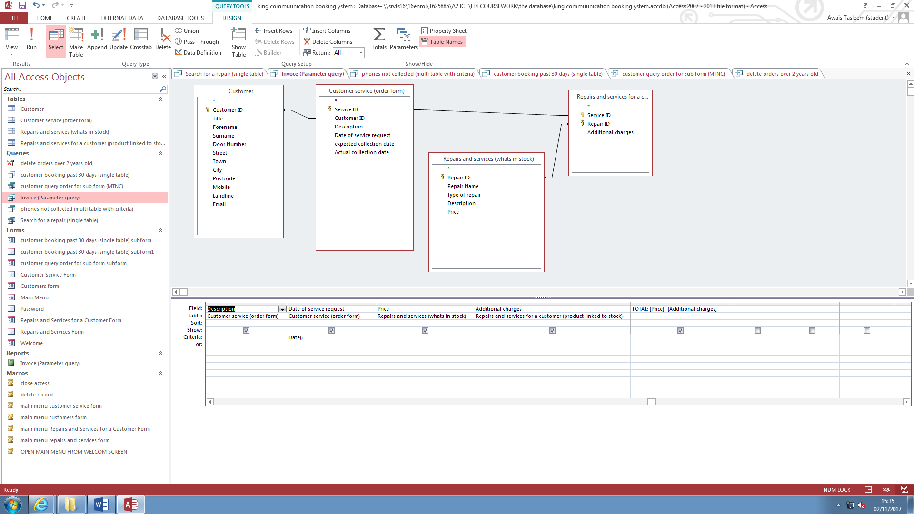

This is the design view of the invoice query. The invoice is the bill of the customer’s order. The criteria is Date(), so that it gets the orders of the customers on today’s date.

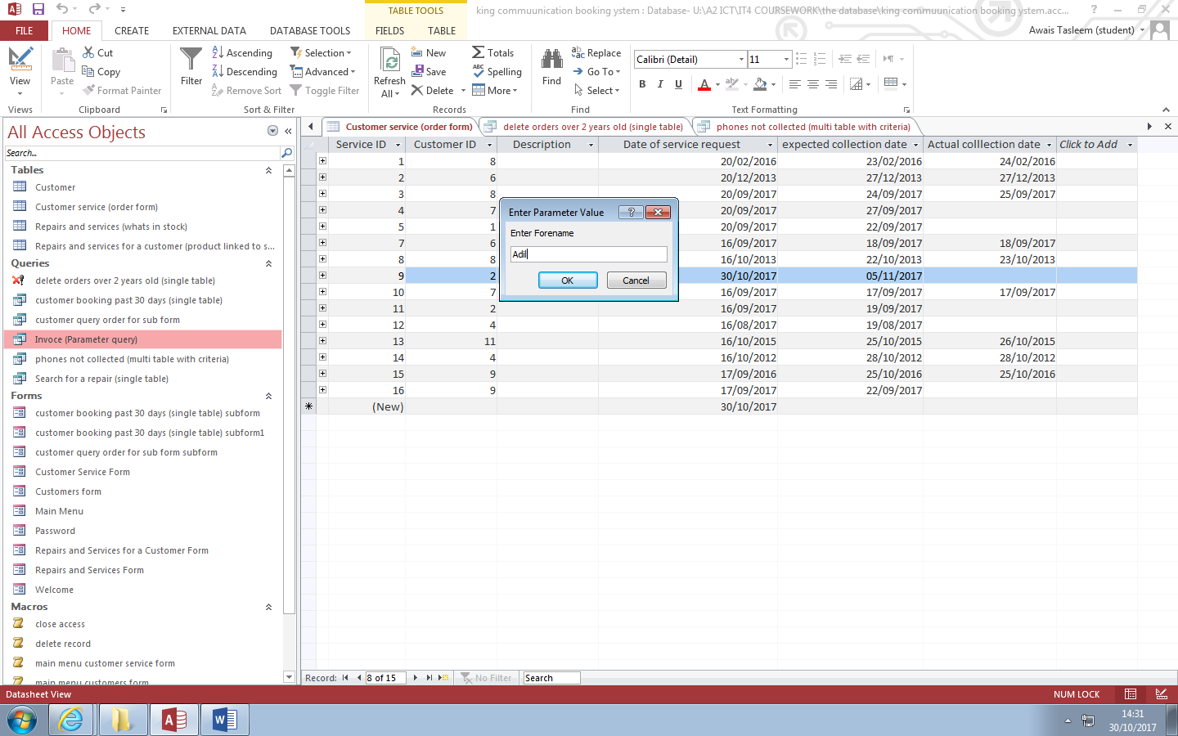

This is me inputting the forename Adil into the search box.

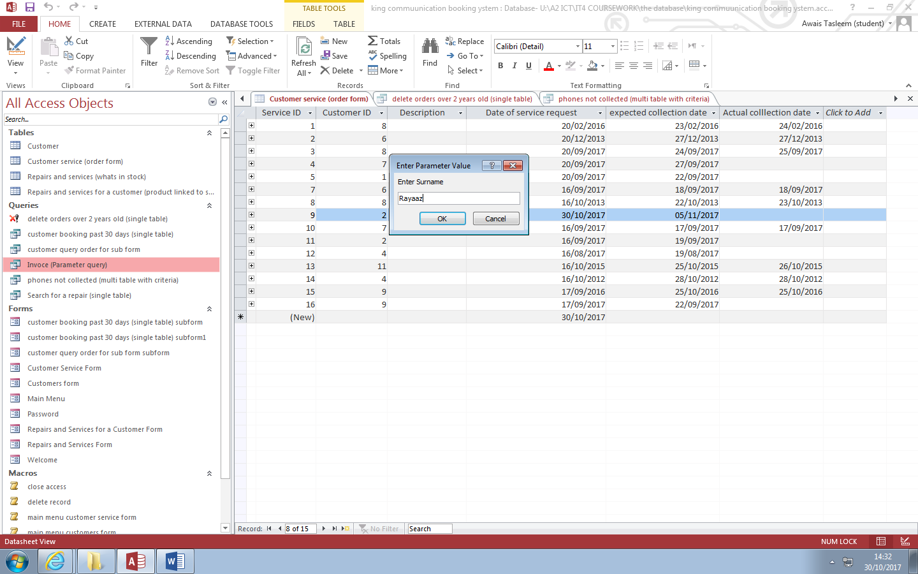

This is me entering the surname Rayaaz in the search box.

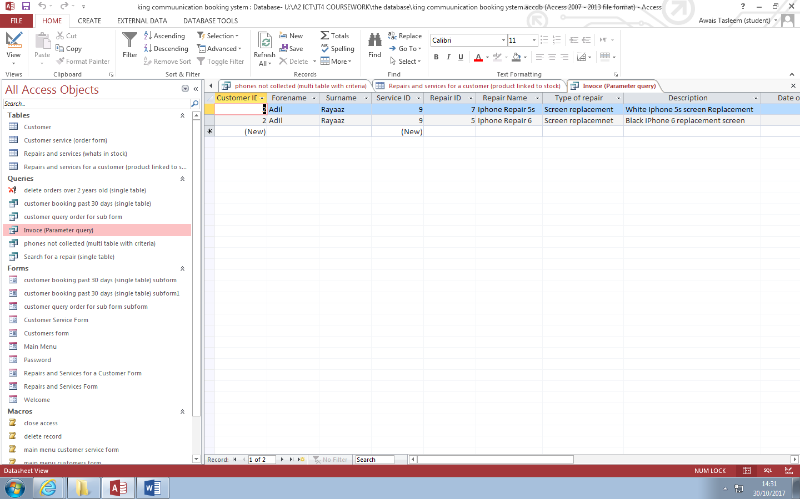

This is the list of all orders that Mr Adil Rayaaz has placed.

**Query 5 – Multi Table with No Criteria**

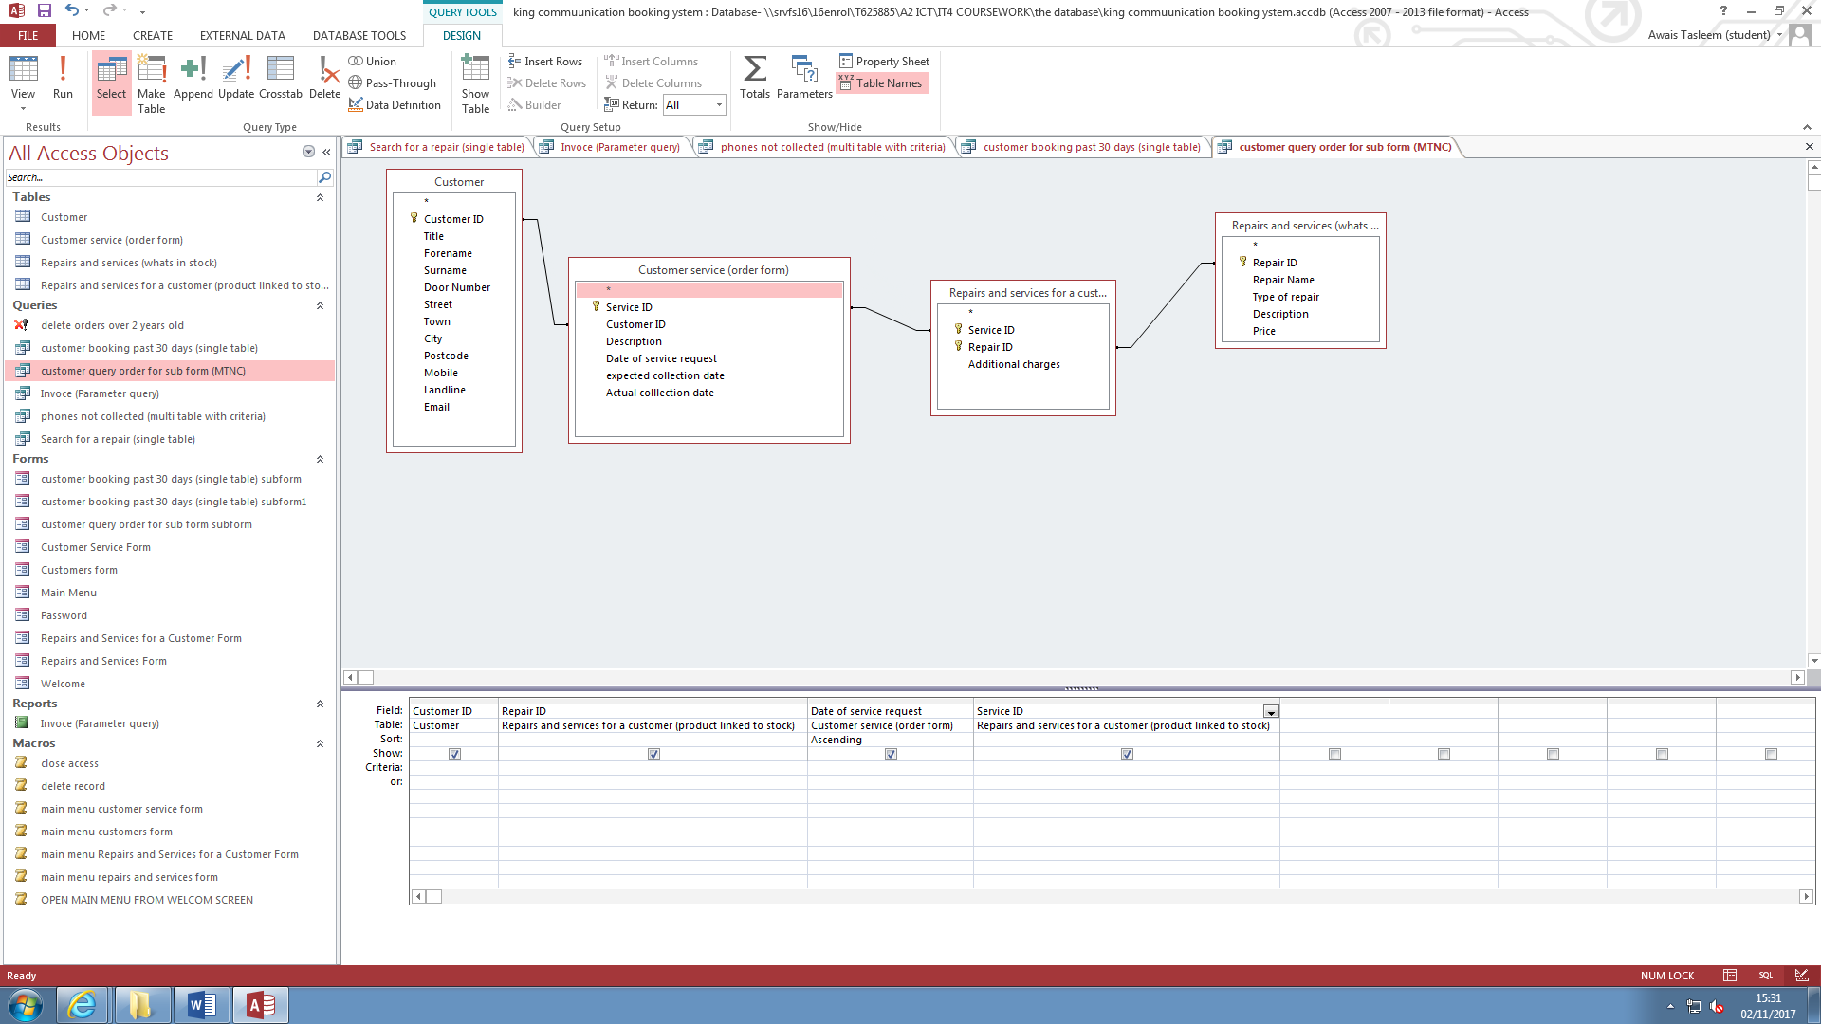

This is the query with no criteria. This query’s job is to find all the past order of a customers when I click on them in the customers form, and then it displays their past order in the sub form.

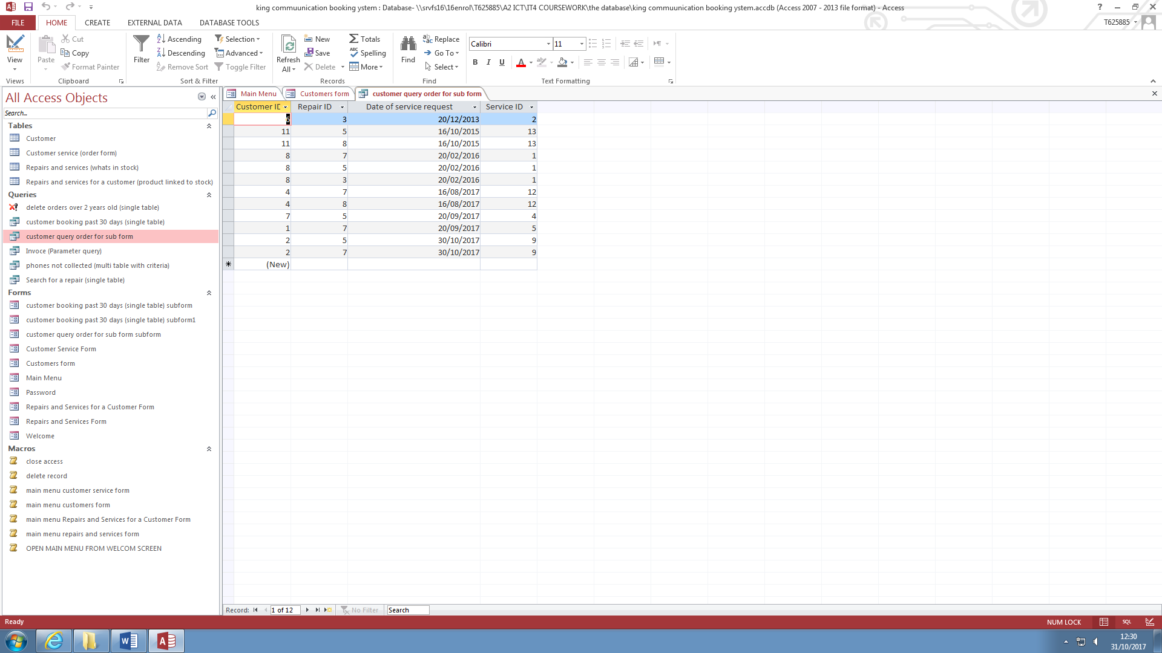

This is the table view of all the past orders of customers.

**Query 6 – Append, or delete or update or queries - delete orders over 2 years old**

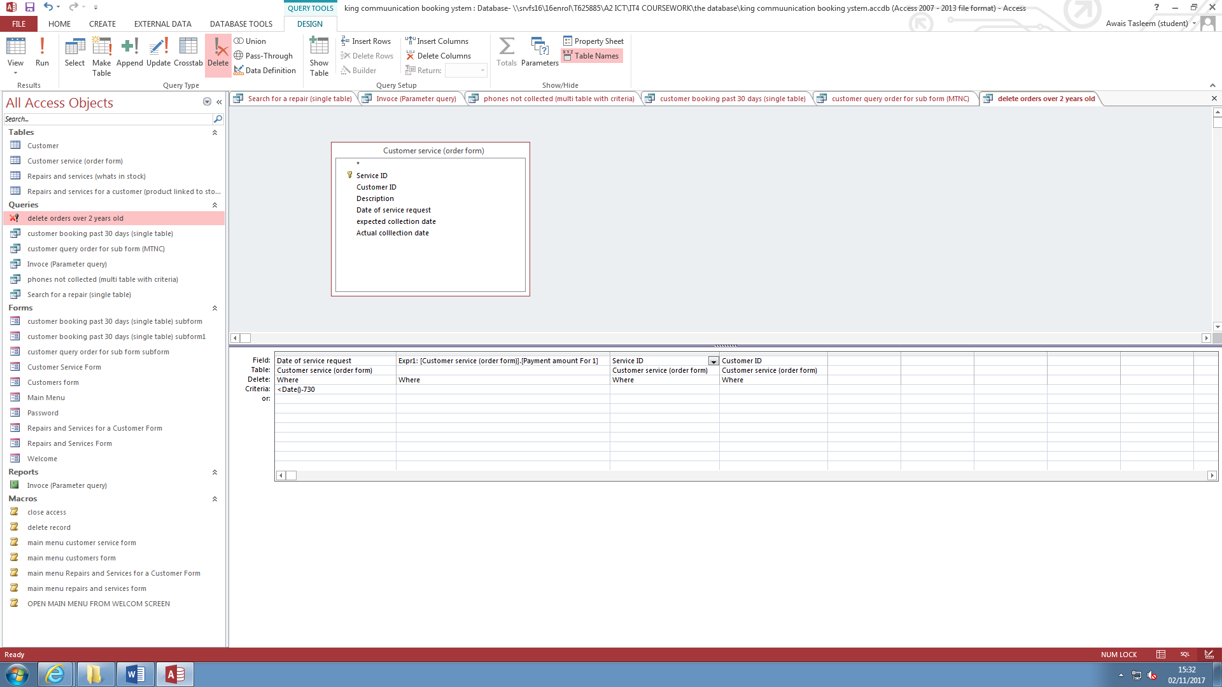

This is the query that deletes past records. I did this so that the user can quickly delete useless data to save storage. The criteria that I use is, <Date()-730 in the date of requested field. This delets any record over 3 years.

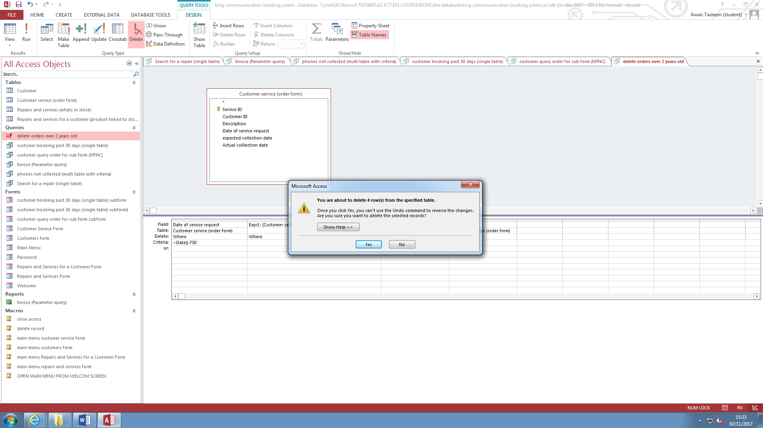

This is the dialogue box. This wanrs the user that 4 rows of records are going to get deleted.

**VB.Net Code**

**Code 1 – Password**

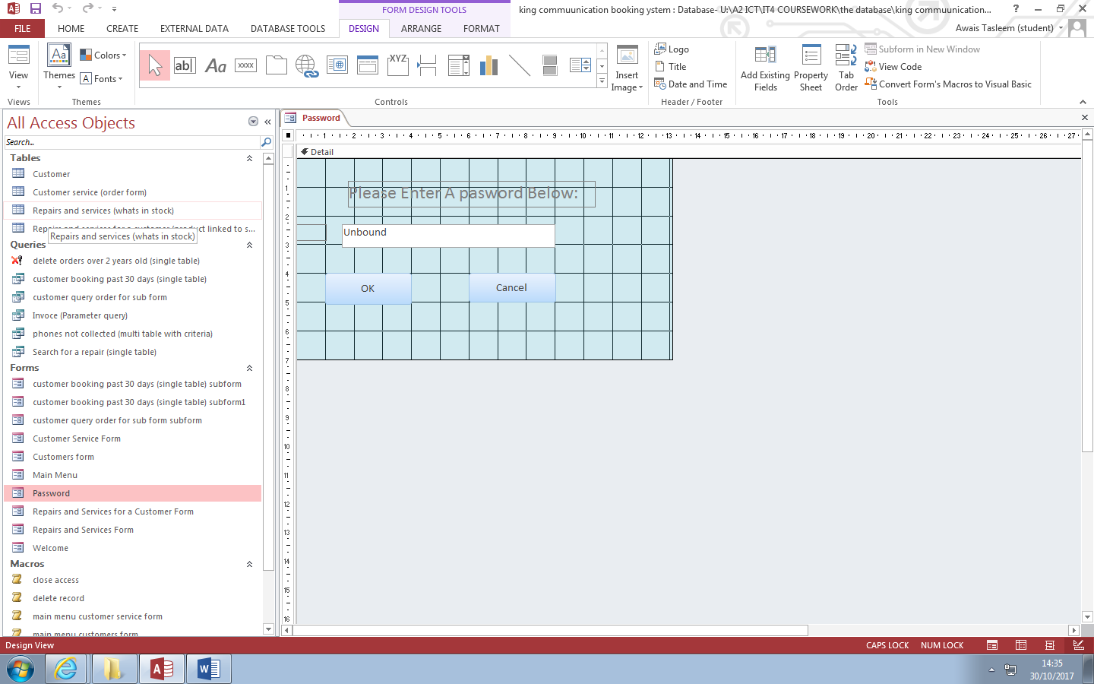

This is the design view of the password form. This is the first thing that the user will see when they open the form. It is there as a security measure to stop any data being viewed by the wrong person.

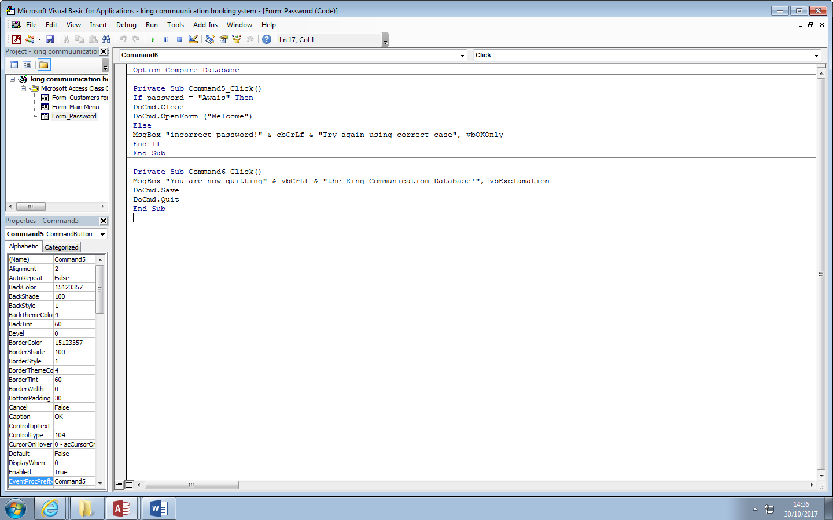This is the code for the password form. Command 5 is the OK button, and command 6 is the cancel button/.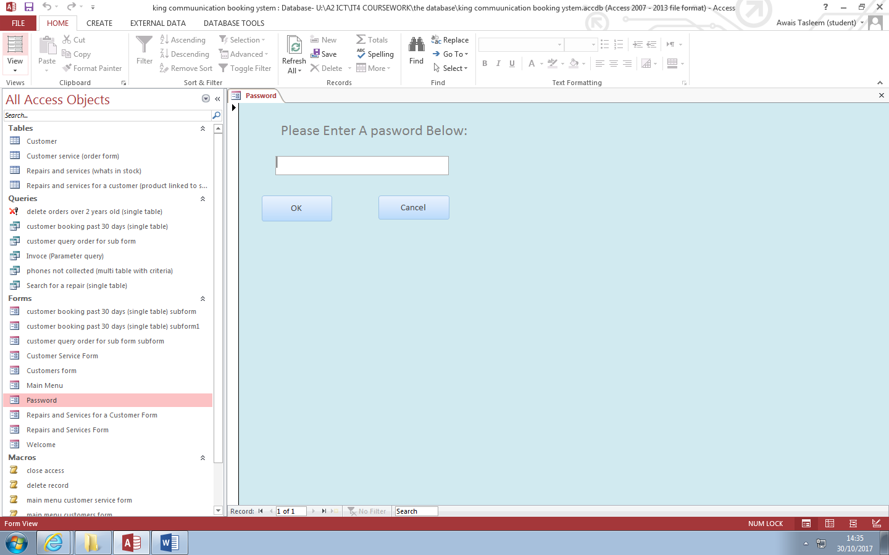

This is the password in form view.

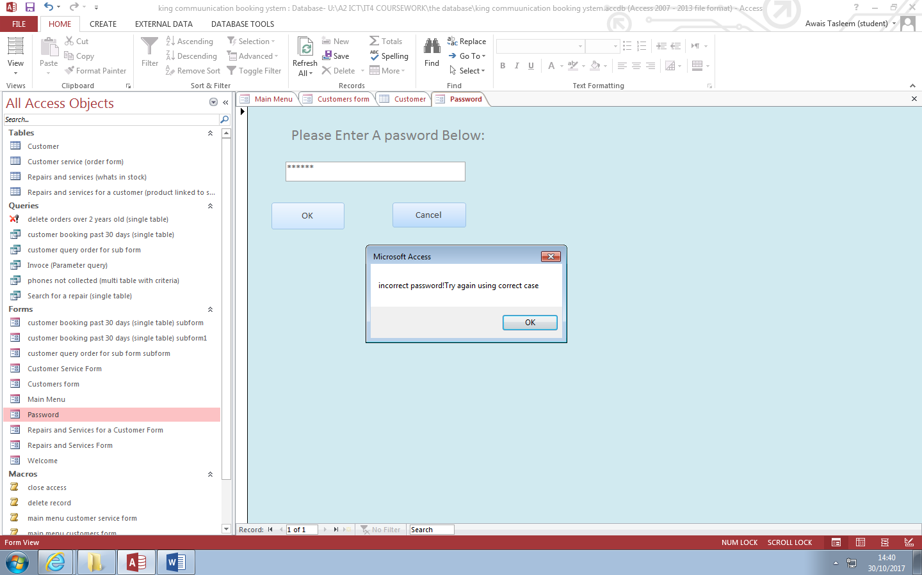

This is the error message that user will get after typing in the wrong password.

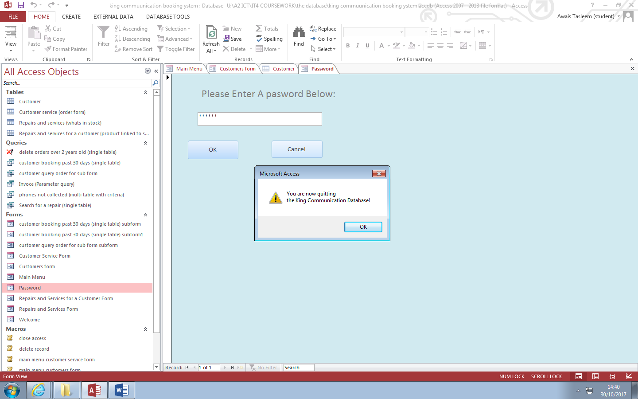

This is the message box the user will get when pressing the cancel button. I will warn them that they are closing the database.

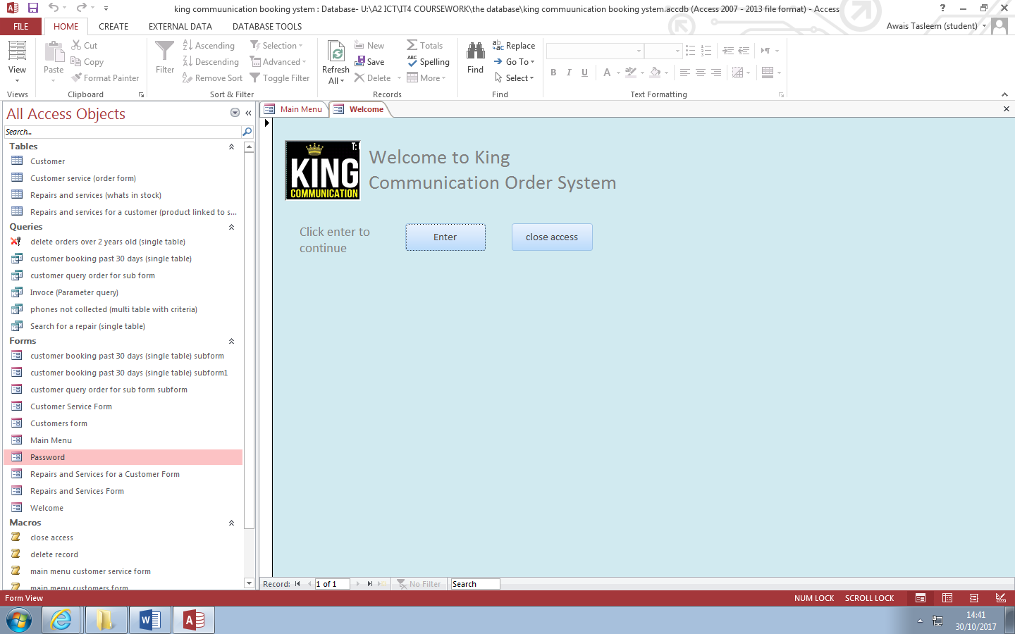

If the user enters the correct password, then he will be shown the welcome form.

**Code 2 – Close App**

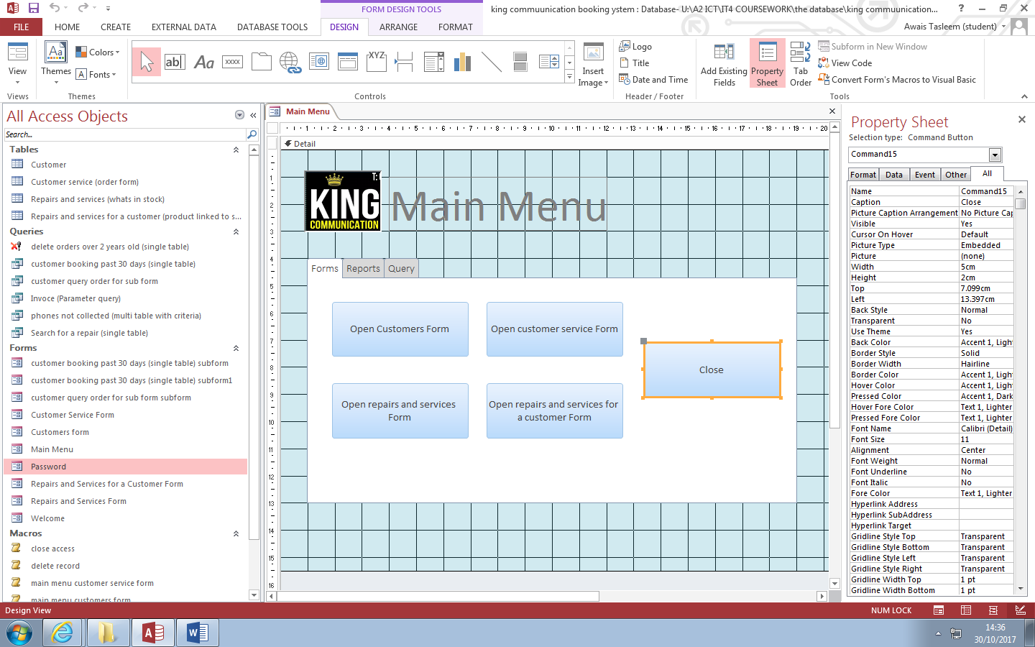

I added VB.Net code to this close button.

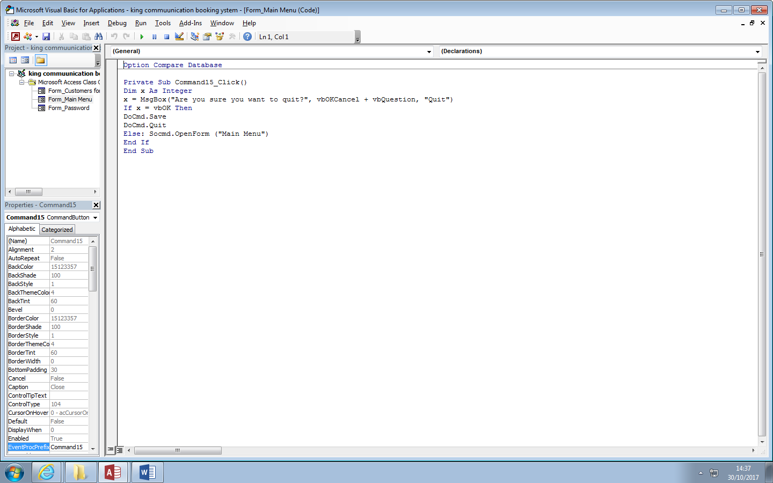

This is the code for the Close button.

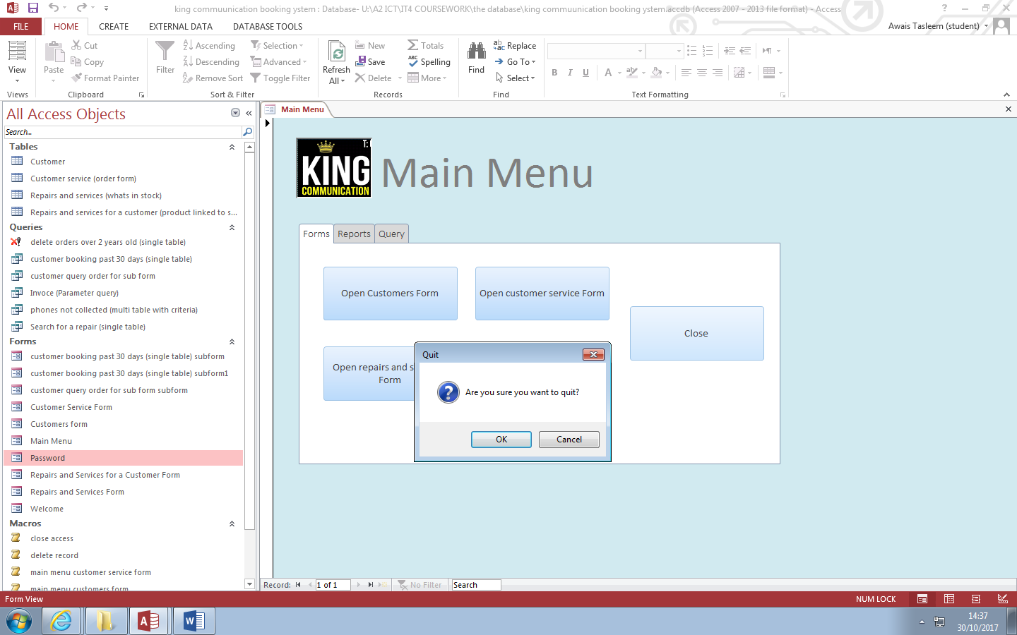

When the user clicks on the close button, a message box will appear, this box will ask the user if he really wants to quit. If the user clicks on OK, then the form will quit, if the user clicks on cancel, then the user will be brought back to the main menu form.

**Code 3 – Search Button**

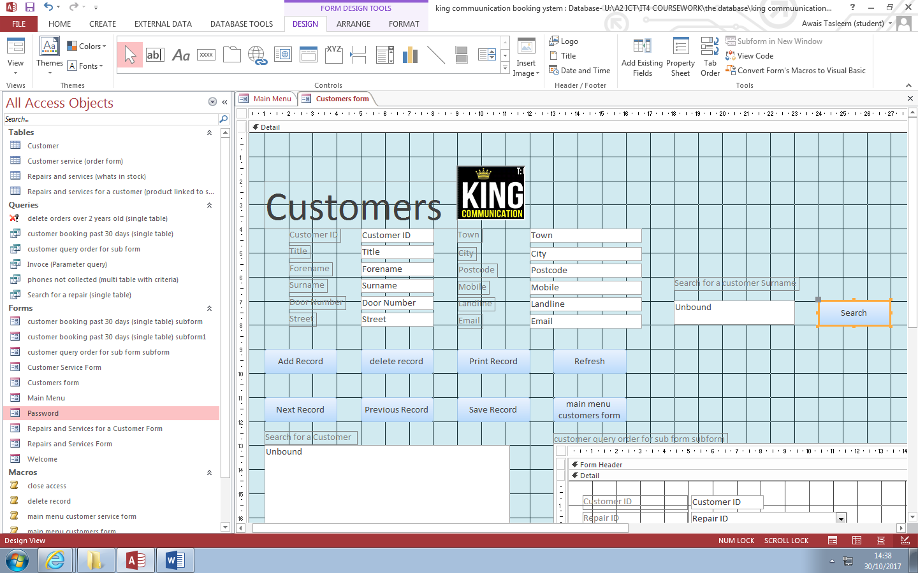

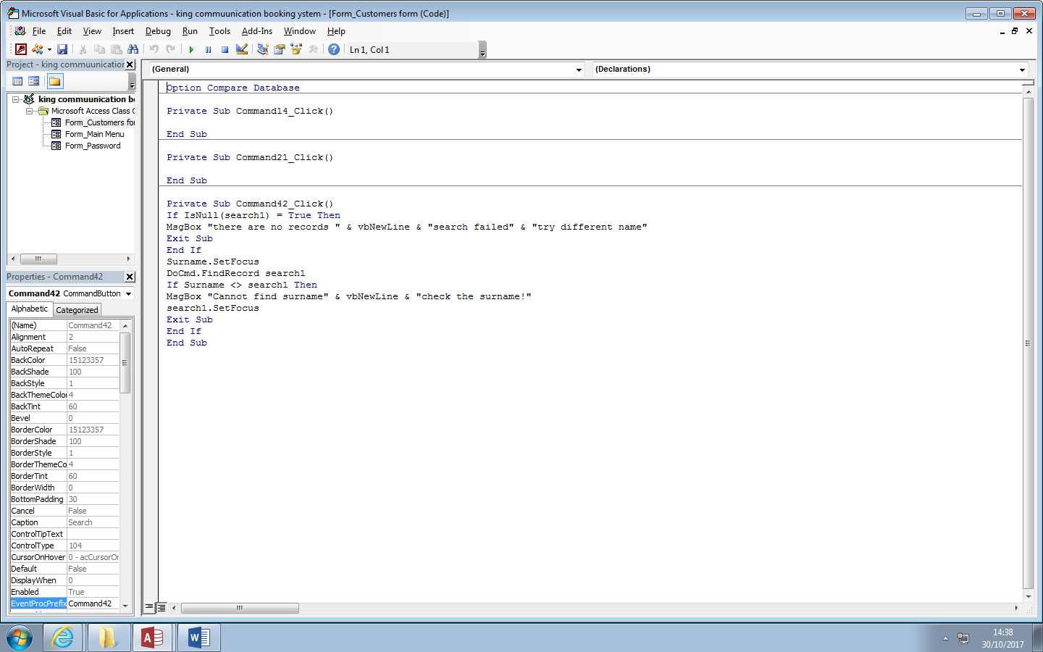

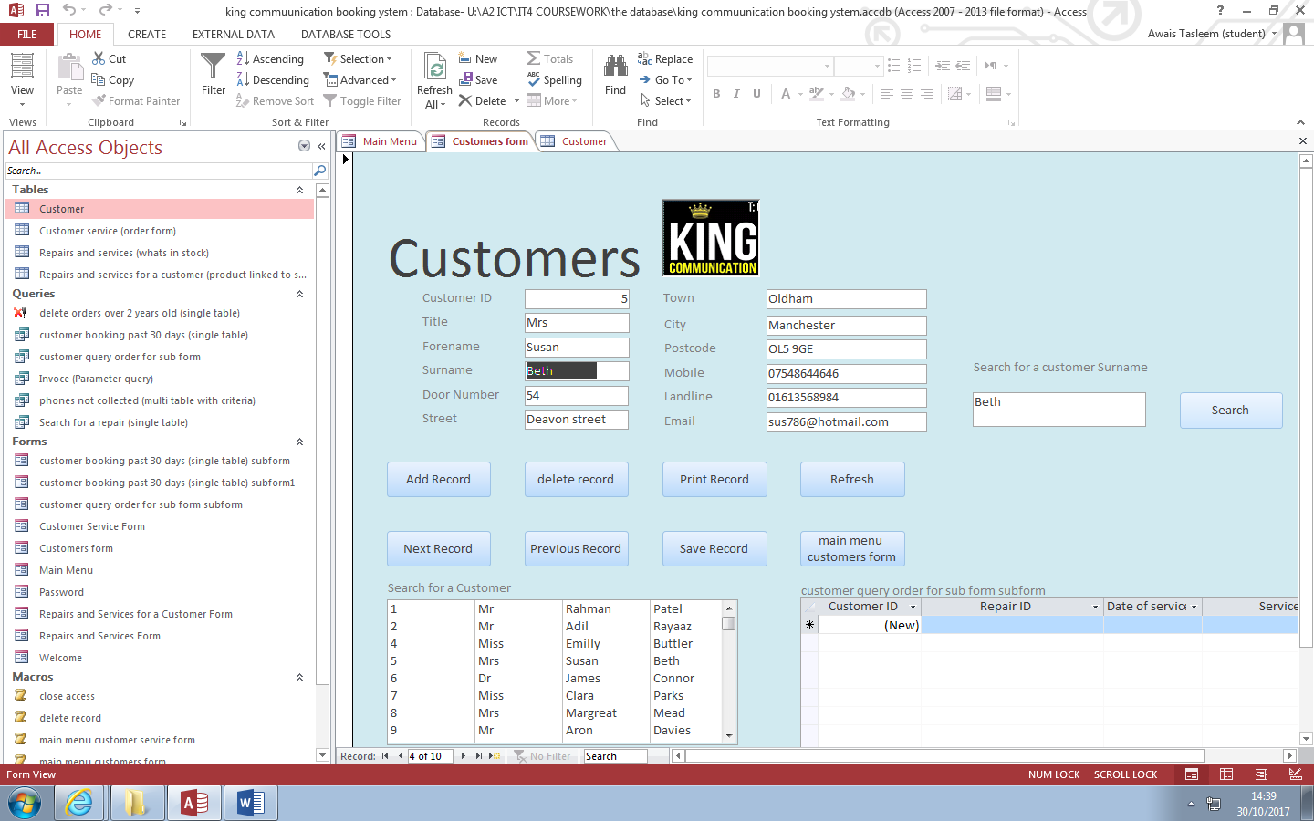

**Report**

